# 10a. Speed up Machine learning

In the lab, you will leverage Redshift for data wrangling which speed up your machine learning use case. You will use Python and Amazon Sagemaker notebook to forecast sales.

## [Contents](https://catalog.us-east-1.prod.workshops.aws/v2/workshops/9f29cdba-66c0-445e-8cbb-28a092cb5ba7/en-US/lab10a" \l "contents)

* [Before You Begin](https://catalog.us-east-1.prod.workshops.aws/v2/workshops/9f29cdba-66c0-445e-8cbb-28a092cb5ba7/en-US/lab10a#before-you-begin)
* [Create Sagemaker notebook instance and setup needed Python library](https://catalog.us-east-1.prod.workshops.aws/v2/workshops/9f29cdba-66c0-445e-8cbb-28a092cb5ba7/en-US/lab10a#create-sagemaker-notebook-instance-and-setup-needed-python-library)
* [Connect to Redshift from your notebook](https://catalog.us-east-1.prod.workshops.aws/v2/workshops/9f29cdba-66c0-445e-8cbb-28a092cb5ba7/en-US/lab10a#connect-to-redshift-from-your-notebook)
* [Exam the sales transaction dataset](https://catalog.us-east-1.prod.workshops.aws/v2/workshops/9f29cdba-66c0-445e-8cbb-28a092cb5ba7/en-US/lab10a#exam-the-sales-transaction-dataset)
* [Use Redshift to cleanup and prepare dataset](https://catalog.us-east-1.prod.workshops.aws/v2/workshops/9f29cdba-66c0-445e-8cbb-28a092cb5ba7/en-US/lab10a#use-redshift-to-cleanup-and-prepare-dataset)
* [Train model and evaluate the model](https://catalog.us-east-1.prod.workshops.aws/v2/workshops/9f29cdba-66c0-445e-8cbb-28a092cb5ba7/en-US/lab10a#train-model-and-evaluate-the-model)
* [Forecast sales for top products](https://catalog.us-east-1.prod.workshops.aws/v2/workshops/9f29cdba-66c0-445e-8cbb-28a092cb5ba7/en-US/lab10a#forecast-sales-for-top-products)
* [Before You Leave](https://catalog.us-east-1.prod.workshops.aws/v2/workshops/9f29cdba-66c0-445e-8cbb-28a092cb5ba7/en-US/lab10a#before-you-leave)

## [Before You Begin](https://catalog.us-east-1.prod.workshops.aws/v2/workshops/9f29cdba-66c0-445e-8cbb-28a092cb5ba7/en-US/lab10a" \l "before-you-begin)

This lab assumes you have launched a Redshift cluster and can gather the following information. If you have not launched a cluster, see [Lab 1 - Creating Redshift Clusters](https://catalog.us-east-1.prod.workshops.aws/v2/workshops/9f29cdba-66c0-445e-8cbb-28a092cb5ba7/en-US/lab1.html).

* [Your-Redshift_Hostname]
* [Your-Redshift_Port]
* [Your-Redshift_Username]
* [Your-Redshift_Password]

## [Create Sagemaker notebook instance and setup needed Python library](https://catalog.us-east-1.prod.workshops.aws/v2/workshops/9f29cdba-66c0-445e-8cbb-28a092cb5ba7/en-US/lab10a" \l "create-sagemaker-notebook-instance-and-setup-needed-python-library)

In AWS console, nevigate to SageMaker, create a new notebook instance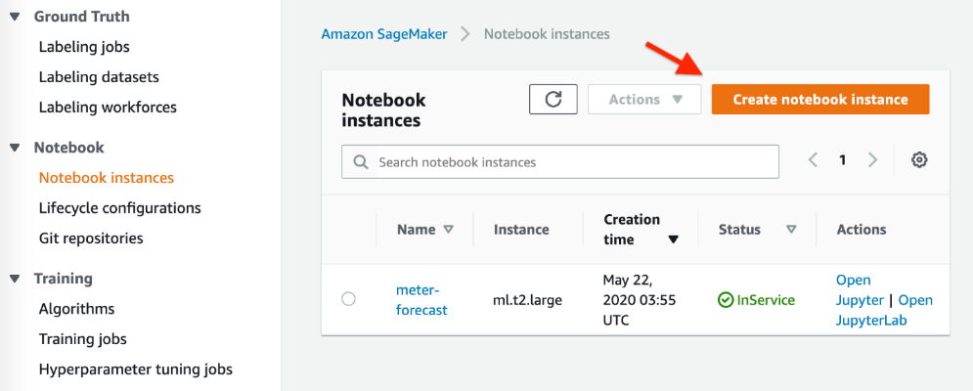Choose the instance type you like. For this lab, we don't need a very powerful one, ml.t2.medium is good enough.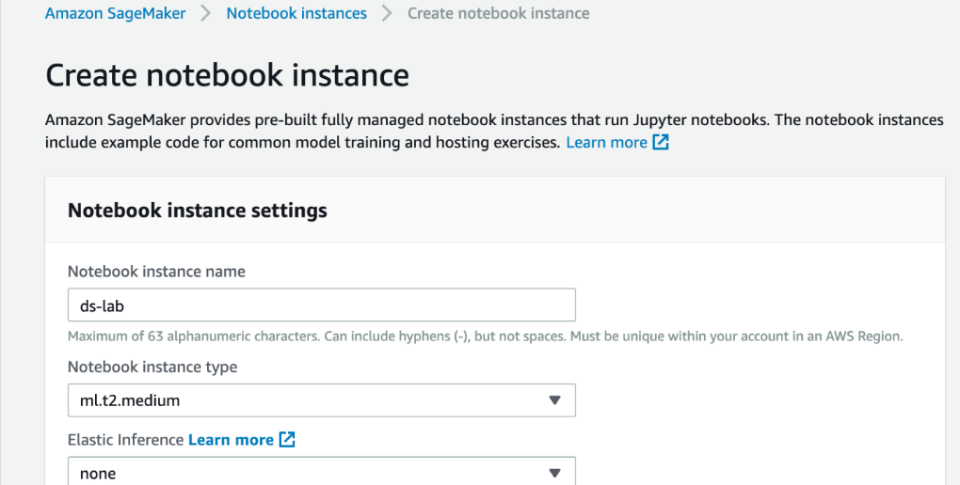Create a new IAM role and select S3 buckets where your machine learning datasets are located.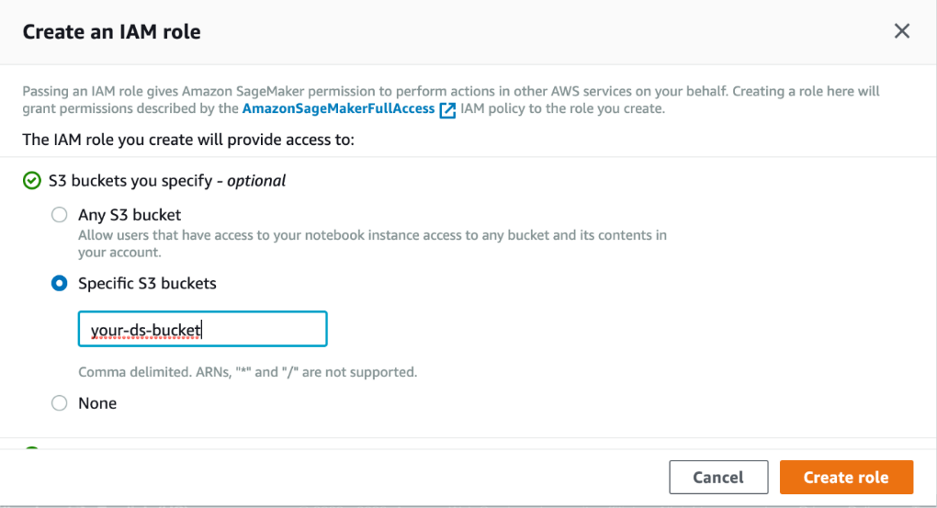Make sure in the Network setting part, choose the same VPC, Subnet, and Security group as your Redshift cluster. This will allow the notebook connect to Redshift easily.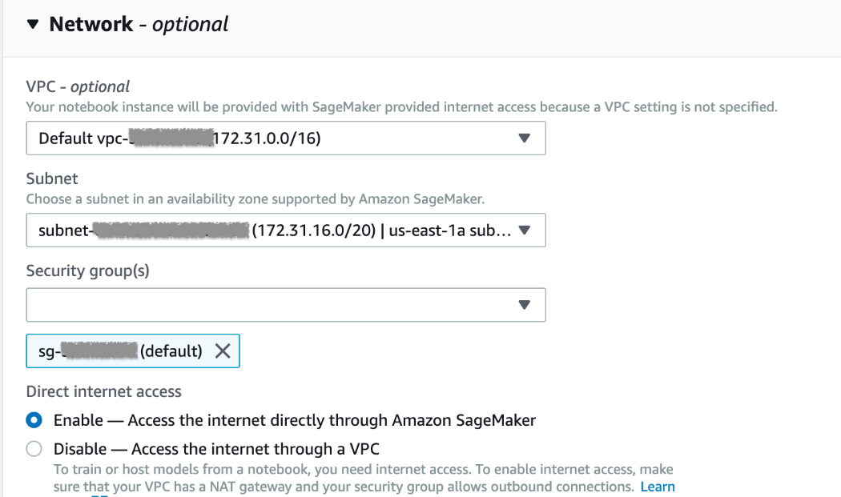Click Create notebook instance. In a few minutes, the instance should be up and running. Find the notebook instance which was launched and click on the Open JupyterLab link.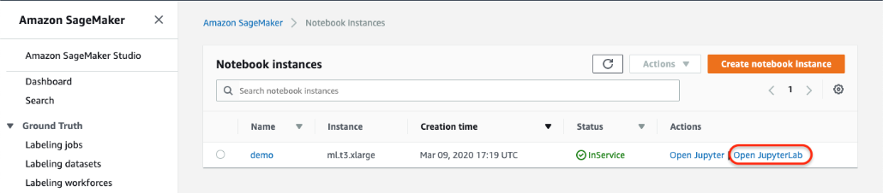In the Notebook UI, create a new notebook with kernal conda_python3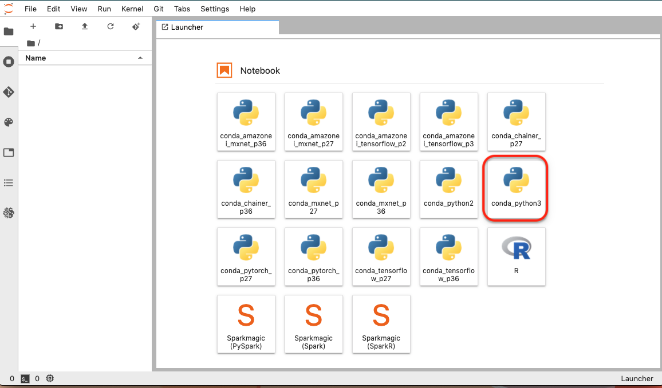

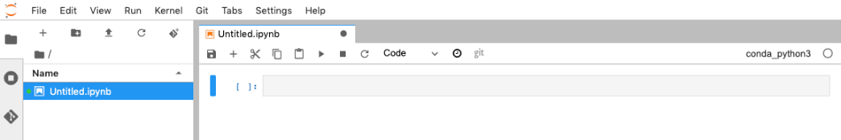Jupyter notebook is an interactive environment where you can run python code, bash command, and SQL (using magic) in interpret mode and see result quickly. First you need to install required Python library by executing the following command in a notebook cell.

!pip install statsmodels

!pip install pmdarima

!pip install awswrangler

!pip install ipython-sql

Add a new cell and paste above code in, then execute. Below animated gif demos how to do it. If a cell is not executed, the left [ ] will be empty, when it's running, it will show as [ * ], after it finishes, it will show a number, e.g. [3]



## [Connect to Redshift from your notebook](https://catalog.us-east-1.prod.workshops.aws/v2/workshops/9f29cdba-66c0-445e-8cbb-28a092cb5ba7/en-US/lab10a" \l "connect-to-redshift-from-your-notebook)

We will use [aws data wrangler](https://github.com/awslabs/aws-data-wrangler) library to connect to Redshift and execute queries. Create a [connection in Glue](https://docs.aws.amazon.com/glue/latest/dg/console-connections.html) named "redshift" first.

In a new cell, paste and execute below code

import awswrangler as wr

# connect to Redshift cluster

# please create a connection in Glue named "redshift" first

connection = wr.redshift.connect("redshift")

# Test connection

results = wr.redshift.read_sql_query(

sql="select current_user, version()",

con=connection

)

results

If connection setup correctly, you should see output like below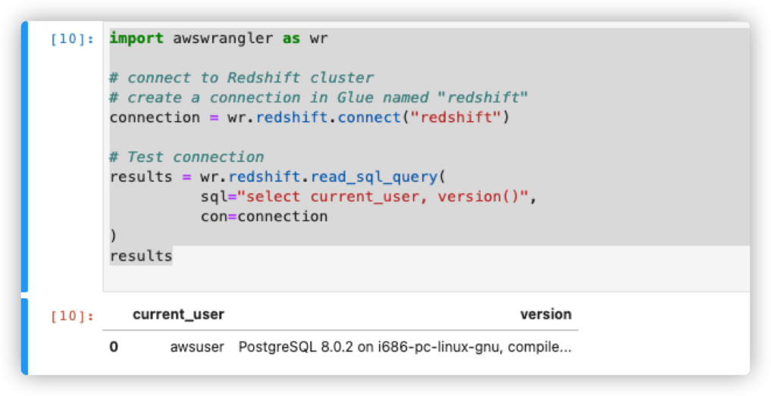

## [Exam the sales transaction dataset](https://catalog.us-east-1.prod.workshops.aws/v2/workshops/9f29cdba-66c0-445e-8cbb-28a092cb5ba7/en-US/lab10a" \l "exam-the-sales-transaction-dataset)

The dataset is located in "s3://redshift-demos/data/sales_forecasting/raw_csv/". you will create an external schema and external table from it and use Redshift Spectrum to access it. To learn more about Spectrum, please review [Lab 4 - Modernize w/ Spectrum](https://catalog.us-east-1.prod.workshops.aws/v2/workshops/9f29cdba-66c0-445e-8cbb-28a092cb5ba7/en-US/lab4.html)

In a new cell, execute below code to create an external schema. Make sure replace the IAM_ROLE to the corresponding one in your environment that has S3 read permission.

query_create_schema = '''

CREATE EXTERNAL SCHEMA IF NOT EXISTS ds_lab

FROM DATA CATALOG DATABASE 'default'

IAM_ROLE 'arn:aws:iam::###account_id###:role/###redshift_role###'

CREATE EXTERNAL DATABASE IF NOT EXISTS;

'''

with engine.connect() as con:

con.cursor().execute(query_create_schema)

Then create an external table via [Redshift QueryEditor](https://console.aws.amazon.com/redshiftv2/home?region=us-east-1#query-editor:) using sample sales data.

CREATE external TABLE ds_lab.sales_raw(

invoiceno varchar(16),

stockcode varchar(16),

description varchar(128),

quantity varchar(16),

invoicedate varchar(32),

unitprice varchar(16),

customerid varchar(16),

country varchar(32)

)

ROW FORMAT SERDE 'org.apache.hadoop.hive.serde2.OpenCSVSerde'

WITH SERDEPROPERTIES (

'serialization.format' = ',',

'field.delim' = ','

)

LOCATION

's3://redshift-demos/data/sales_forecasting/raw_csv/'

TABLE PROPERTIES (

'skip.header.line.count'='1');

Now you can exam the dataset without loading it into Redshift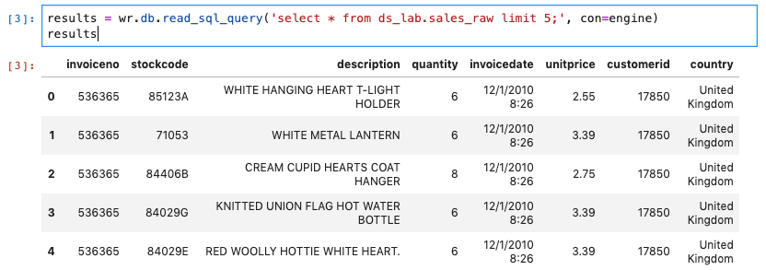

## [Use Redshift to cleanup and prepare dataset](https://catalog.us-east-1.prod.workshops.aws/v2/workshops/9f29cdba-66c0-445e-8cbb-28a092cb5ba7/en-US/lab10a" \l "use-redshift-to-cleanup-and-prepare-dataset)

The dataset is not ready for forecasting. It contains bad data, null, missing values, etc. For example:

* Description is null
* CustomerID could be null
* Quantity is null
* Damaged, wrong order, missing, sample, adjustment ... Should remove those record
* UnitPrice = 0 those records should be removed
* Some dates don't have any sales.

Before we run machine learning algorithm to build model, we need to clean up the data. 80% of data scientist's time is spent on data wrangling. Let's see how to use Redshift to quickly cleanup the data. Execute below code in a new cell to create a new table and store cleaned data.

query_create_table = '''

create table public.sales_clean as

select invoiceno, stockcode, TO_DATE(invoicedate, 'MM/DD/YYYY HH24:MI') as invoicedate,

cast(quantity as bigint) as quantity,

cast(unitprice as float) as unitprice,

country from ds_lab.sales_raw

where

trim(unitprice) not like '0'

and stockcode not in ('B', 'D', 'M', 'm', 'S');

'''

with engine.connect().execution_options(autocommit=True) as con:

con.cursor().execute(query_create_table)

### [Challenges:](https://catalog.us-east-1.prod.workshops.aws/v2/workshops/9f29cdba-66c0-445e-8cbb-28a092cb5ba7/en-US/lab10a" \l "challenges:)

Instead of CTAS, you can use [materialzed view](https://docs.amazonaws.cn/en_us/redshift/latest/dg/materialized-view-create-sql-command.html) to process and store cleaned data and easily refresh it by calling REFRESH materialized view after new data added. Depend on where the source table stored and the query pattern, it could qualify for incremental refresh and shorten the data wrangling time even further.

Now the data is ready for model training and forecasting. First, you will aggregate the sales by date, then split it into training and testing set. For standard machine learning tasks such as classification and regression, one typically obtains this split by randomly separating examples into train and test sets. However, in forecasting it is important to do this train/test split based on time rather than by time series. here we use first 10 months data for training, and rest for testing.

import pandas as pd

import numpy as np

import matplotlib.pyplot as plt

daily_sales = '''select date_trunc('day', invoicedate) as invoicedate, sum(quantity * unitprice) as total_sales from public.sales_clean group by 1 order by 1;'''

df = wr.redshift.read_sql_query(sql=daily_sales, con=engine)

result = df.set_index('invoicedate')

result = result.resample('1D').sum()

traindata = np.trim_zeros(result.iloc[:,0], trim='f')

train = traindata[50:330]

test = traindata[330:]

result.plot(figsize=(15,8))

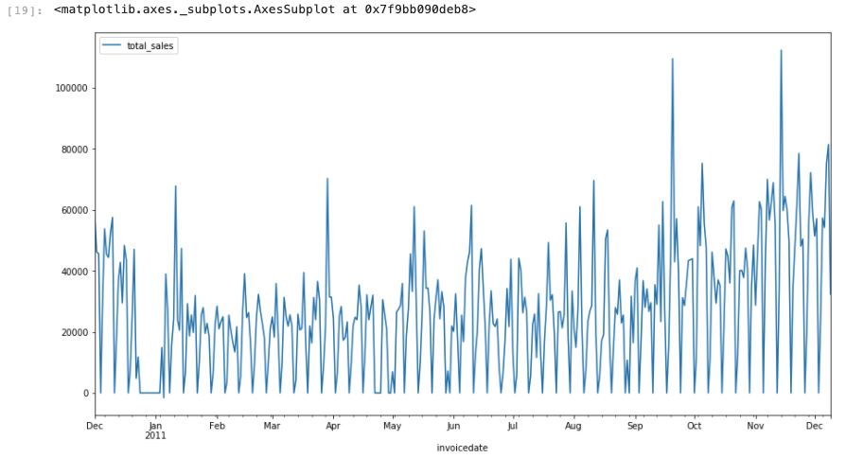

One of the most widely studied models in time series forecasting is ARIMA (autoregressive integrated moving average) model. The sales dataset used here has seasonality so we will use SARIMA model. you can decompose the time series data to see it's trend, seasonality, and noise

from pylab import rcParams

import statsmodels.api as sm

rcParams['figure.figsize'] = 15, 8

decomposition = sm.tsa.seasonal_decompose(result, model='additive')

fig = decomposition.plot()

plt.show()

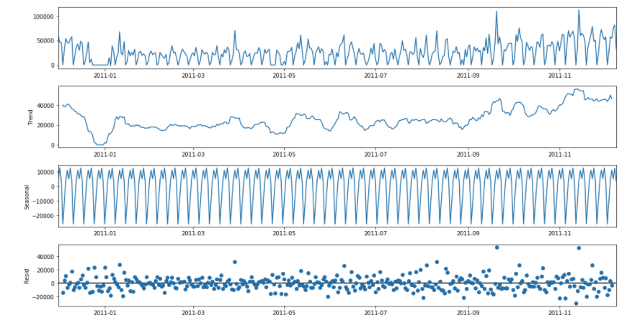

## [Train model and evaluate the model](https://catalog.us-east-1.prod.workshops.aws/v2/workshops/9f29cdba-66c0-445e-8cbb-28a092cb5ba7/en-US/lab10a" \l "train-model-and-evaluate-the-model)

To simplify the model tuning, we will use pmdarima python library to automatically select best parameters.

import pmdarima as pm

from statsmodels.tsa.arima_model import ARIMA

from random import random

smodel = pm.auto_arima(train, start_p=1, start_q=1,

test='adf',

max_p=3, max_q=3, m=12,

start_P=0, seasonal=True,

d=None, D=1, trace=True,

error_action='ignore',

suppress_warnings=True,

stepwise=True)

smodel.summary()

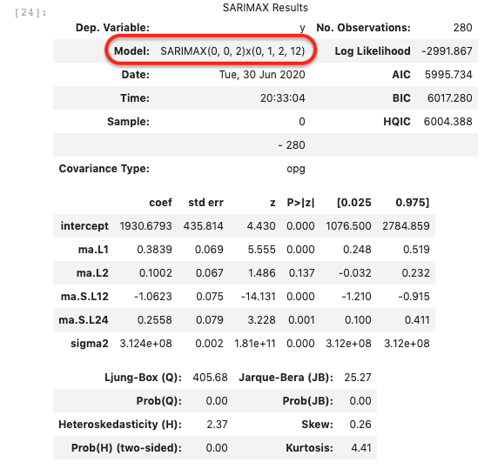

We used the first 10 months data to train the model, If we run the prediction, we can compare the result with the testing dataset to evaluate the model.

import matplotlib.pyplot as plt

n_periods = 30

fitted, confint = smodel.predict(n_periods=n_periods, return_conf_int=True)

index_of_fc = pd.date_range(train.index[-1], periods = n_periods, freq='D')

fitted_series = pd.Series(fitted, index=index_of_fc)

lower_series = pd.Series(confint[:, 0], index=index_of_fc)

upper_series = pd.Series(confint[:, 1], index=index_of_fc)

# Plot

plt.figure(figsize=(12,5), dpi=100)

plt.plot(train[:], label='training')

plt.plot(test[:30], label='actual')

plt.plot(fitted_series, color='darkgreen', label='forecast')

plt.fill_between(lower_series.index,

lower_series,

upper_series,

color='k', alpha=.15)

plt.legend(loc='upper left', fontsize=8)

plt.title("Forecast of sales vs actual")

plt.show()

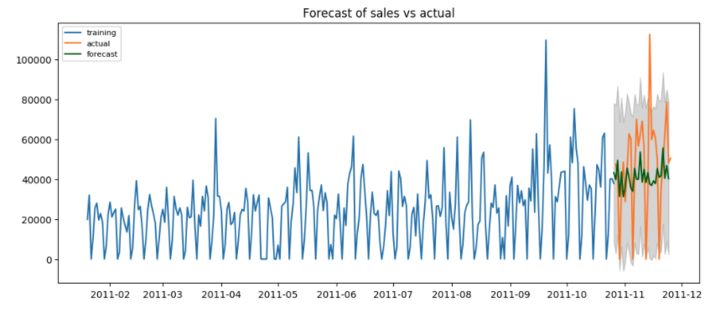

## [Forecast sales for top products](https://catalog.us-east-1.prod.workshops.aws/v2/workshops/9f29cdba-66c0-445e-8cbb-28a092cb5ba7/en-US/lab10a" \l "forecast-sales-for-top-products)

Now we can use the model to forecast popular product sales in next 30 days. and visualize the result.

from statsmodels.tsa.statespace.sarimax import SARIMAX

prodcode = '22633'

daily_prod_sales = '''select date_trunc('day', invoicedate) as invoicedate, sum(quantity * unitprice) as total_sales from public.sales_clean where stockcode = '%s' group by 1 order by 1;'''

df = wr.redshift.read_sql_query(daily_prod_sales % prodcode, con=engine)

df_prod = df.set_index('invoicedate')

df_prod = df_prod.resample('1D').sum()

forecast_period = 30

prod_data = df_prod['total_sales']

train_prod = prod_data[:]

forecast_index = pd.date_range(start=df_prod.index[df_prod.size-1], freq='1D', periods=forecast_period)

my_order = (0,0,2)

my_seasonal_order = (0, 1, 2, 12)

model = SARIMAX(train_prod, order=my_order, seasonal_order=my_seasonal_order)

# train the model and run forecast

model_fit = model.fit()

fc = model_fit.forecast(forecast_period, alpha=0.05)

fc_series = pd.Series(fc, index=forecast_index)

fig = plt.figure(figsize=(12,5), dpi=100)

plt.plot(train_prod[df_prod.size-45:], label='actual')

plt.plot(fc_series[:], label='forecast')

plt.title('%d days Forecast for product %s' % (forecast_period, prodcode))

plt.legend(loc='upper left', fontsize=8)

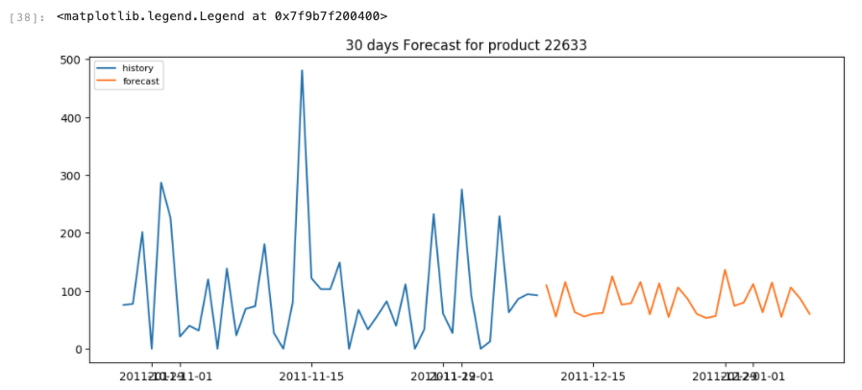

Here is how the complete notebook looks like: (or click here: [sales forecasting](https://catalog.us-east-1.prod.workshops.aws/v2/workshops/9f29cdba-66c0-445e-8cbb-28a092cb5ba7/en-US/post/sales_forecasting.html) ) {{< html.inline >}}

## [Before You Leave](https://catalog.us-east-1.prod.workshops.aws/v2/workshops/9f29cdba-66c0-445e-8cbb-28a092cb5ba7/en-US/lab10a" \l "before-you-leave)

If you are done using your cluster, please think about decommissioning it to avoid having to pay for unused resources, as well as terminating the Sagemaker notebook instance. Note Sagemaker notebook instance can be stopped and started later with all notebooks preserved. If you want to continue your work later, you can just stop it.

# 10b. Speed up Machine learning (SageMaker Studio)

In the lab, you will leverage Redshift for data wrangling which speed up your machine learning use case. You will use Python and Amazon Sagemaker Studio to forecast sales.

## [Contents](https://catalog.us-east-1.prod.workshops.aws/v2/workshops/9f29cdba-66c0-445e-8cbb-28a092cb5ba7/en-US/lab10b" \l "contents)

* [Before You Begin](https://catalog.us-east-1.prod.workshops.aws/v2/workshops/9f29cdba-66c0-445e-8cbb-28a092cb5ba7/en-US/lab10b#before-you-begin)
* [Setup Sagemaker Studio domain and create python notebook](https://catalog.us-east-1.prod.workshops.aws/v2/workshops/9f29cdba-66c0-445e-8cbb-28a092cb5ba7/en-US/lab10b#setup-sagemaker-studio-domain-and-create-python-notebook)
* [Connect to Redshift from your notebook](https://catalog.us-east-1.prod.workshops.aws/v2/workshops/9f29cdba-66c0-445e-8cbb-28a092cb5ba7/en-US/lab10b#connect-to-redshift-from-your-notebook)
* [Exam the sales transaction dataset](https://catalog.us-east-1.prod.workshops.aws/v2/workshops/9f29cdba-66c0-445e-8cbb-28a092cb5ba7/en-US/lab10b#exam-the-sales-transaction-dataset)
* [Use Redshift to cleanup and prepare dataset](https://catalog.us-east-1.prod.workshops.aws/v2/workshops/9f29cdba-66c0-445e-8cbb-28a092cb5ba7/en-US/lab10b#use-redshift-to-cleanup-and-prepare-dataset)
* [Train model and evaluate the model](https://catalog.us-east-1.prod.workshops.aws/v2/workshops/9f29cdba-66c0-445e-8cbb-28a092cb5ba7/en-US/lab10b#train-model-and-evaluate-the-model)
* [Forecast sales for top products](https://catalog.us-east-1.prod.workshops.aws/v2/workshops/9f29cdba-66c0-445e-8cbb-28a092cb5ba7/en-US/lab10b#forecast-sales-for-top-products)
* [Before You Leave](https://catalog.us-east-1.prod.workshops.aws/v2/workshops/9f29cdba-66c0-445e-8cbb-28a092cb5ba7/en-US/lab10b#before-you-leave)

## [Before You Begin](https://catalog.us-east-1.prod.workshops.aws/v2/workshops/9f29cdba-66c0-445e-8cbb-28a092cb5ba7/en-US/lab10b" \l "before-you-begin)

This lab assumes you have launched a Redshift cluster and can gather the following information. If you have not launched a cluster, see [Lab 1 - Creating Redshift Clusters](https://catalog.us-east-1.prod.workshops.aws/v2/workshops/9f29cdba-66c0-445e-8cbb-28a092cb5ba7/en-US/lab1.html).

* [Your-Redshift_Hostname]
* [Your-Redshift_Port]
* [Your-Redshift_Username]
* [Your-Redshift_Password]
* [VPC where your Redshift cluster is deployed]
* [Private subnet in above VPC]

## [Setup Sagemaker Studio domain and create python notebook](https://catalog.us-east-1.prod.workshops.aws/v2/workshops/9f29cdba-66c0-445e-8cbb-28a092cb5ba7/en-US/lab10b" \l "setup-sagemaker-studio-domain-and-create-python-notebook)

In AWS console, nevigate to [SageMaker](https://console.aws.amazon.com/sagemaker/home?region=us-east-1#/studio), create a Sagemaker Studio domain. Choose Standard setup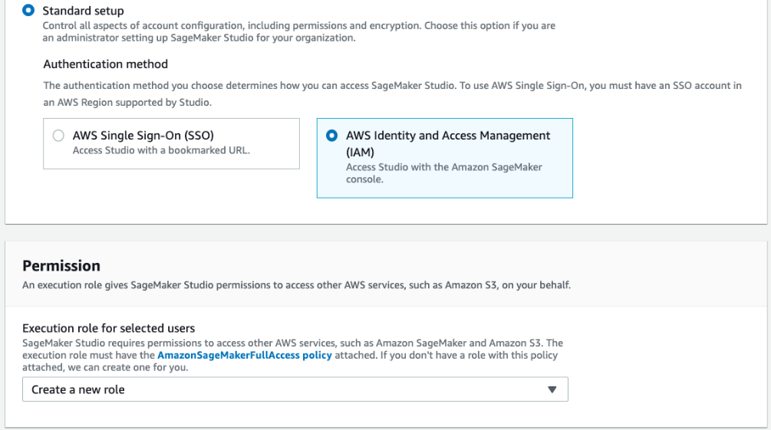Click Network and storage setting, choose the VPC where your Redshift cluster is deployed, and a private subnet from the same VPC (Note there should be a NAT gateway setup to allow internet access from the private subnet. See this [blog](https://aws.amazon.com/blogs/machine-learning/securing-amazon-sagemaker-studio-internet-traffic-using-aws-network-firewall/) for more details.); Select VPC only mode under Network Access, then select the same Security group your Redshift cluster use.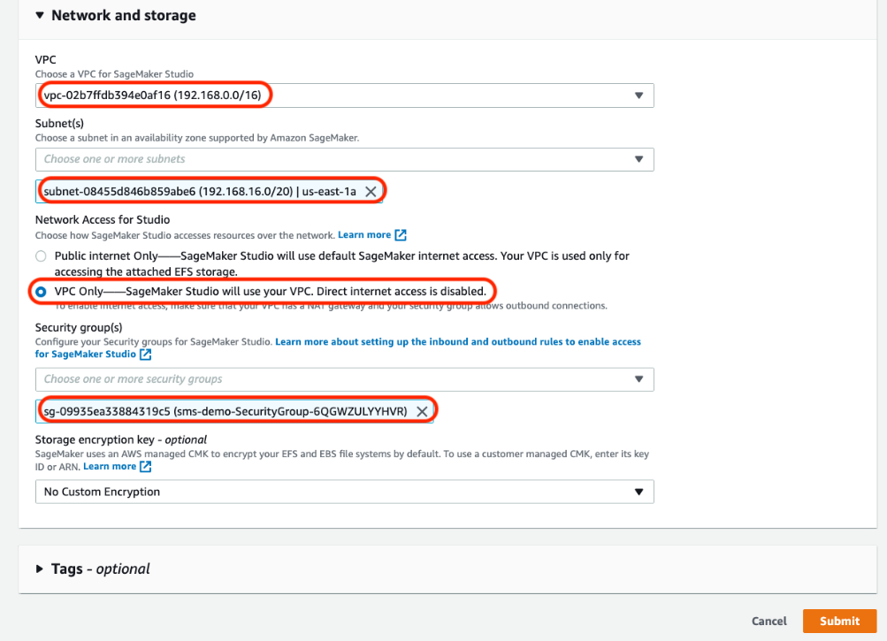Click Submit, you will see Studio domain is being created. Note that you can have only one Sagemaker Studio domain in one AWS account.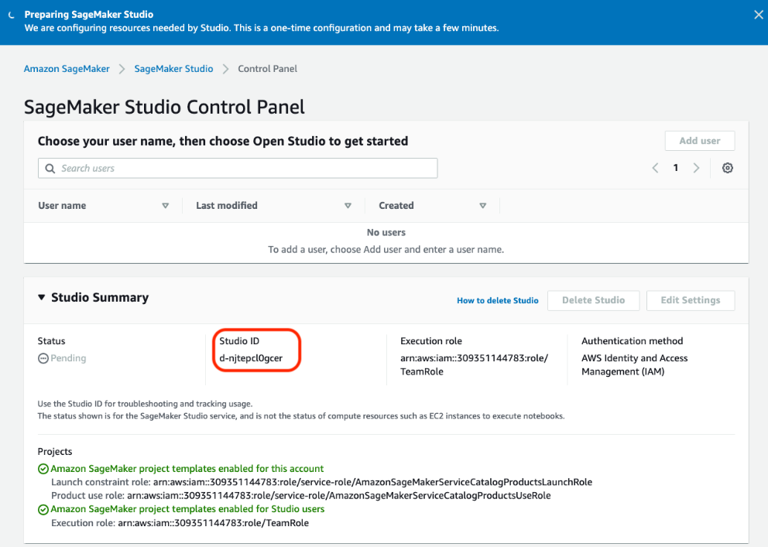Once Sagemaker Studio is ready, you can add users.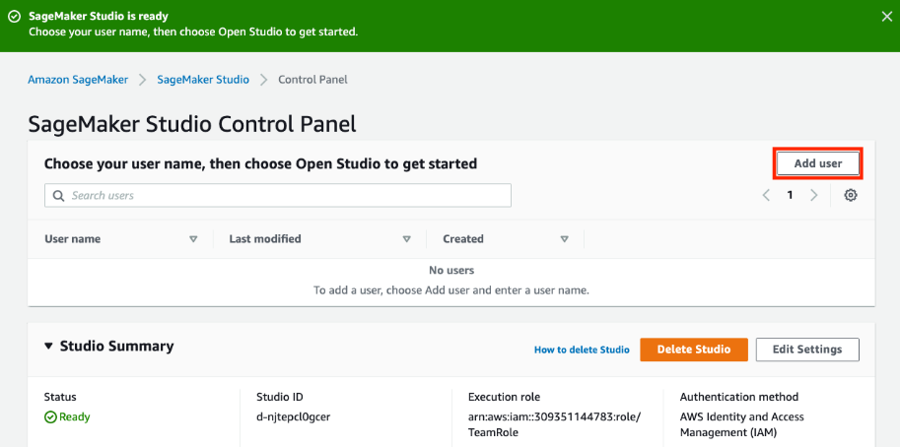After user is created, click Open Studio. The first time you open studio, SageMaker will create the default JupyterServer application and redirect you there, this may take a few minutes. Now you can create your notebook. Depend on which image you choose, it may trigger another application to be created.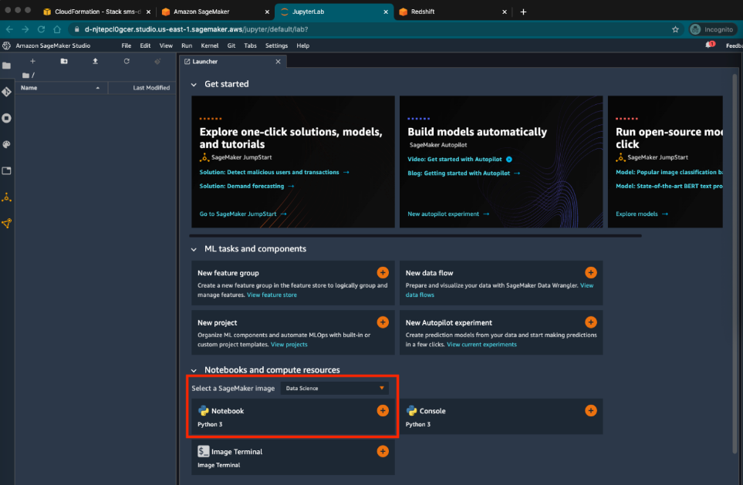For this lab, we will choose the Data Science one. You should see two Apps under user details page.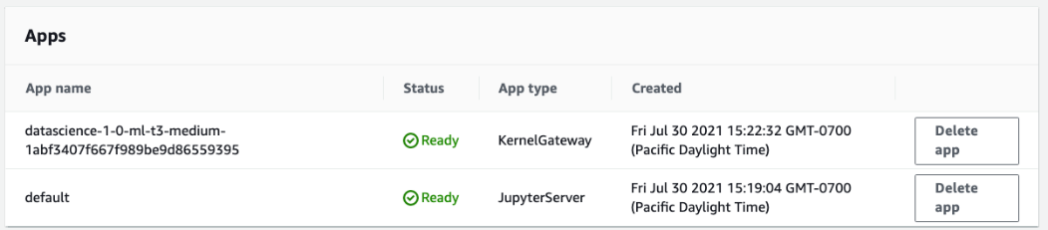

Jupyter notebook is an interactive environment where you can run python code, bash command, and SQL (using magic) in interpret mode and see result quickly. First you need to install required Python library by executing the following command in a notebook cell.

!pip install ipython-sql

!pip install psycopg2-binary

!pip install statsmodels

!pip install pmdarima

Add a new cell and paste above code in, then execute. Below animated gif demos how to do it. If a cell is not executed, the left [ ] will be empty, when it's running, it will show as [ * ], after it finishes, it will show a number, e.g. [3]

## [Connect to Redshift from your notebook](https://catalog.us-east-1.prod.workshops.aws/v2/workshops/9f29cdba-66c0-445e-8cbb-28a092cb5ba7/en-US/lab10b" \l "connect-to-redshift-from-your-notebook)

Create a connection.json file with the Redshift cluster info you collected from CloudFormation output in below format. (Watch below animated gif for how to do it)

{

"host_name" : "[Your-Redshift_Hostname]",

"port_num" : "[Your-Redshift_Port]",

"username" : "[Your-Redshift_Username]",

"password" : "[Your-Redshift_Password]",

"db_name" : "[Your-Redshift_Database]"

}



Now we are ready to connect to Redshift cluster. We will use psycopg library to connect to Redshift and execute queries. In a new cell, paste and execute below code

import json, os, boto3

from IPython import get_ipython

ipython = get_ipython()

if 'ipython' in globals():

print('\nWelcome to IPython!')

ipython.magic('reload_ext sql')

ipython.magic('config SqlMagic.displaylimit = 25')

# connect to Redshift cluster

data = {}

with open('connection.json') as f:

data = json.load(f)

connect_to_db = 'postgresql+psycopg2://%s:%s@%s:%s/%s' % (data['username'],data['password'],data['host_name'],data['port_num'],data['db_name'])

%sql $connect_to_db

%sql select current_user, version();

If connection setup correctly, you should see output like below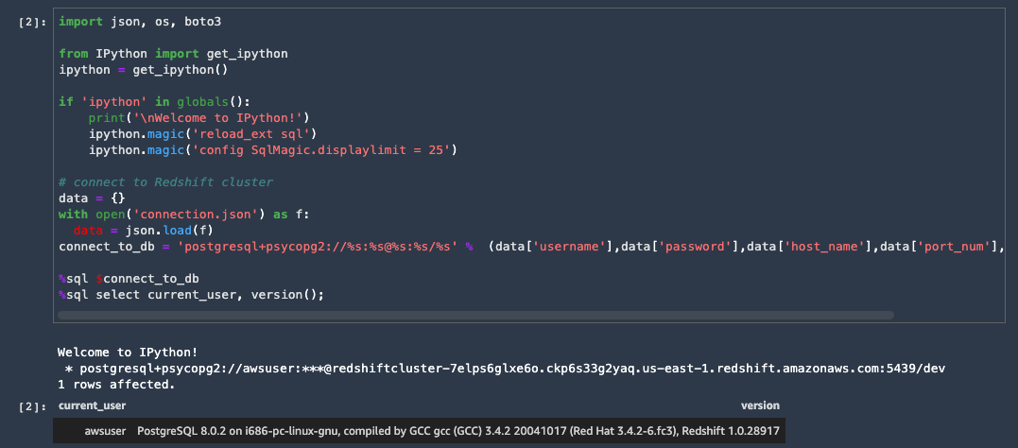

## [Exam the sales transaction dataset](https://catalog.us-east-1.prod.workshops.aws/v2/workshops/9f29cdba-66c0-445e-8cbb-28a092cb5ba7/en-US/lab10b" \l "exam-the-sales-transaction-dataset)

The dataset is located in "s3://redshift-demos/data/sales_forecasting/raw_csv/". you will create an external schema and external table from it and use Redshift Spectrum to access it. To learn more about Spectrum, please review [Lab 4 - Modernize w/ Spectrum](https://catalog.us-east-1.prod.workshops.aws/v2/workshops/9f29cdba-66c0-445e-8cbb-28a092cb5ba7/en-US/lab4.html)

In a new cell, execute below code to create an external schema. Make sure replace the IAM_ROLE to the corresponding one in your environment that has S3 read permission.

%%sql

CREATE EXTERNAL SCHEMA IF NOT EXISTS ds_lab

FROM DATA CATALOG DATABASE 'default'

IAM_ROLE 'arn:aws:iam::###account_id###:role/###redshift_role###'

CREATE EXTERNAL DATABASE IF NOT EXISTS;

Then create an external table via [Redshift QueryEditor](https://console.aws.amazon.com/redshiftv2/home?region=us-east-1#query-editor:) using sample sales data.

CREATE external TABLE ds_lab.sales_raw(

invoiceno varchar(16),

stockcode varchar(16),

description varchar(128),

quantity varchar(16),

invoicedate varchar(32),

unitprice varchar(16),

customerid varchar(16),

country varchar(32)

)

ROW FORMAT SERDE 'org.apache.hadoop.hive.serde2.OpenCSVSerde'

WITH SERDEPROPERTIES (

'serialization.format' = ',',

'field.delim' = ','

)

LOCATION

's3://redshift-demos/data/sales_forecasting/raw_csv/'

TABLE PROPERTIES (

'skip.header.line.count'='1');

select * from ds_lab.sales_raw limit 5;

Now you can exam the dataset without loading it into Redshift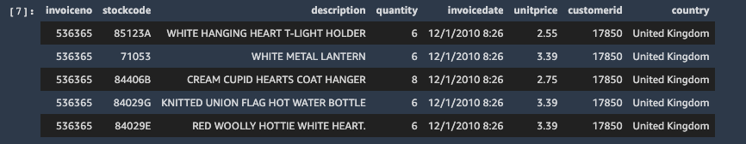

## [Use Redshift to cleanup and prepare dataset](https://catalog.us-east-1.prod.workshops.aws/v2/workshops/9f29cdba-66c0-445e-8cbb-28a092cb5ba7/en-US/lab10b" \l "use-redshift-to-cleanup-and-prepare-dataset)

The dataset is not ready for forecasting. It contains bad data, null, missing values, etc. For example:

* Description is null
* CustomerID could be null
* Quantity is null
* Damaged, wrong order, missing, sample, adjustment ... Should remove those record
* UnitPrice = 0 those records should be removed
* Some dates don't have any sales.

Before we run machine learning algorithm to build model, we need to clean up the data. 80% of data scientist's time is spent on data wrangling. Let's see how to use Redshift to quickly cleanup the data. Execute below code in a new cell to create a new table and store cleaned data.

%%sql

create table public.sales_clean as

select invoiceno, stockcode, TO_DATE(invoicedate, 'MM/DD/YYYY HH24:MI') as invoicedate,

cast(quantity as bigint) as quantity,

cast(unitprice as float) as unitprice,

country from ds_lab.sales_raw

where

trim(unitprice) not like '0'

and stockcode not in ('B', 'D', 'M', 'm', 'S');

select * from sales_clean limit 5;

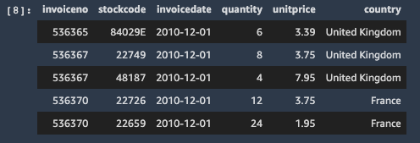

### [Challenges:](https://catalog.us-east-1.prod.workshops.aws/v2/workshops/9f29cdba-66c0-445e-8cbb-28a092cb5ba7/en-US/lab10b" \l "challenges:)

Instead of CTAS, you can use [materialzed view](https://docs.amazonaws.cn/en_us/redshift/latest/dg/materialized-view-create-sql-command.html) to process and store cleaned data and easily refresh it by calling REFRESH materialized view after new data added. Depend on where the source table stored and the query pattern, it could qualify for incremental refresh and shorten the data wrangling time even further.

Now the data is ready for model training and forecasting. First, you will aggregate the sales by date, then split it into training and testing set. For standard machine learning tasks such as classification and regression, one typically obtains this split by randomly separating examples into train and test sets. However, in forecasting it is important to do this train/test split based on time rather than by time series. here we use first 10 months data for training, and rest for testing.

import pandas as pd

import numpy as np

import matplotlib.pyplot as plt

daily_sales = '''select date_trunc('day', invoicedate) as invoicedate, sum(quantity * unitprice) as total_sales from public.sales_clean group by 1 order by 1;'''

df = pd.read_sql(daily_sales, connect_to_db)

result = df.set_index('invoicedate')

result = result.resample('1D').sum()

traindata = np.trim_zeros(result.iloc[:,0], trim='f')

train = traindata[50:330]

test = traindata[330:]

result.plot(figsize=(15,8))



One of the most widely studied models in time series forecasting is ARIMA (autoregressive integrated moving average) model. The sales dataset used here has seasonality so we will use SARIMA model. you can decompose the time series data to see it's trend, seasonality, and noise

from pylab import rcParams

import statsmodels.api as sm

rcParams['figure.figsize'] = 15, 8

decomposition = sm.tsa.seasonal_decompose(result, model='additive')

fig = decomposition.plot()

plt.show()



## [Train model and evaluate the model](https://catalog.us-east-1.prod.workshops.aws/v2/workshops/9f29cdba-66c0-445e-8cbb-28a092cb5ba7/en-US/lab10b" \l "train-model-and-evaluate-the-model)

To simplify the model tuning, we will use pmdarima python library to automatically select best parameters.

import pmdarima as pm

from statsmodels.tsa.arima_model import ARIMA

from random import random

smodel = pm.auto_arima(train, start_p=1, start_q=1,

test='adf',

max_p=3, max_q=3, m=12,

start_P=0, seasonal=True,

d=None, D=1, trace=True,

error_action='ignore',

suppress_warnings=True,

stepwise=True)

smodel.summary()



We used the first 10 months data to train the model, If we run the prediction, we can compare the result with the testing dataset to evaluate the model.

import matplotlib.pyplot as plt

n_periods = 30

fitted, confint = smodel.predict(n_periods=n_periods, return_conf_int=True)

index_of_fc = pd.date_range(train.index[-1], periods = n_periods, freq='D')

fitted_series = pd.Series(fitted, index=index_of_fc)

lower_series = pd.Series(confint[:, 0], index=index_of_fc)

upper_series = pd.Series(confint[:, 1], index=index_of_fc)

# Plot

plt.figure(figsize=(12,5), dpi=100)

plt.plot(train[:], label='training')

plt.plot(test[:30], label='actual')

plt.plot(fitted_series, color='darkgreen', label='forecast')

plt.fill_between(lower_series.index,

lower_series,

upper_series,

color='k', alpha=.15)

plt.legend(loc='upper left', fontsize=8)

plt.title("Forecast of sales vs actual")

plt.show()



## [Forecast sales for top products](https://catalog.us-east-1.prod.workshops.aws/v2/workshops/9f29cdba-66c0-445e-8cbb-28a092cb5ba7/en-US/lab10b" \l "forecast-sales-for-top-products)

Now we can use the model to forecast popular product sales in next 30 days. and visualize the result.

from statsmodels.tsa.statespace.sarimax import SARIMAX

prodcode = '22633'

daily_prod_sales = '''select date_trunc('day', invoicedate) as invoicedate, sum(quantity * unitprice) as total_sales from public.sales_clean where stockcode = '%s' group by 1 order by 1;'''

df = pd.read_sql(daily_prod_sales % prodcode, connect_to_db)

df_prod = df.set_index('invoicedate')

df_prod = df_prod.resample('1D').sum()

forecast_period = 30

prod_data = df_prod['total_sales']

train_prod = prod_data[:]

forecast_index = pd.date_range(start=df_prod.index[df_prod.size-1], freq='1D', periods=forecast_period)

my_order = (0,0,2)

my_seasonal_order = (0, 1, 2, 12)

model = SARIMAX(train_prod, order=my_order, seasonal_order=my_seasonal_order)

# train the model and run forecast

model_fit = model.fit()

fc = model_fit.forecast(forecast_period, alpha=0.05)

fc_series = pd.Series(fc, index=forecast_index)

fig = plt.figure(figsize=(12,5), dpi=100)

plt.plot(train_prod[df_prod.size-45:], label='actual')

plt.plot(fc_series[:], label='forecast')

plt.title('%d days Forecast for product %s' % (forecast_period, prodcode))

plt.legend(loc='upper left', fontsize=8)



Here is how the complete notebook looks like: (or click here: [sales forecasting](https://catalog.us-east-1.prod.workshops.aws/v2/workshops/9f29cdba-66c0-445e-8cbb-28a092cb5ba7/en-US/post/sales_forecasting.html) ) {{< html.inline >}}

## [Before You Leave](https://catalog.us-east-1.prod.workshops.aws/v2/workshops/9f29cdba-66c0-445e-8cbb-28a092cb5ba7/en-US/lab10b" \l "before-you-leave)

If you are done using your cluster, please think about decommissioning it to avoid having to pay for unused resources, as well as terminating the Sagemaker notebook instance. Note Sagemaker notebook instance can be stopped and started later with all notebooks preserved. If you want to continue your work later, you can just stop it

# 11. Oracle to Redshift Migration

This lab demonstrates how we can use AWS Schema Conversion Tool (AWS SCT) and AWS Database Migration Service (DMS) to migrate data and code (DDL structures and the PL/SQL code) from an Oracle database to Amazon Redshift. It also demonstrates how AWS DMS to continually replicate database changes (ongoing updates) from the source database to the target database.

## [Contents](https://catalog.us-east-1.prod.workshops.aws/v2/workshops/9f29cdba-66c0-445e-8cbb-28a092cb5ba7/en-US/lab11" \l "contents)

* [Architecture](https://catalog.us-east-1.prod.workshops.aws/v2/workshops/9f29cdba-66c0-445e-8cbb-28a092cb5ba7/en-US/lab11#architecture)
* [Before you Begin](https://catalog.us-east-1.prod.workshops.aws/v2/workshops/9f29cdba-66c0-445e-8cbb-28a092cb5ba7/en-US/lab11#before-you-begin)
* [1. Convert the Schema](https://catalog.us-east-1.prod.workshops.aws/v2/workshops/9f29cdba-66c0-445e-8cbb-28a092cb5ba7/en-US/lab11#2-convert-the-schema)
* [2. Migrate the data](https://catalog.us-east-1.prod.workshops.aws/v2/workshops/9f29cdba-66c0-445e-8cbb-28a092cb5ba7/en-US/lab11#3-migrate-the-data)
* [3. Keep the data in sync](https://catalog.us-east-1.prod.workshops.aws/v2/workshops/9f29cdba-66c0-445e-8cbb-28a092cb5ba7/en-US/lab11#4-keep-the-data-in-sync)
* [Before You Leave](https://catalog.us-east-1.prod.workshops.aws/v2/workshops/9f29cdba-66c0-445e-8cbb-28a092cb5ba7/en-US/lab11#before-you-leave)

## [Architecture](https://catalog.us-east-1.prod.workshops.aws/v2/workshops/9f29cdba-66c0-445e-8cbb-28a092cb5ba7/en-US/lab11" \l "architecture)

To solve the challenge, here is the architecture that you would be going through in this lab:

* Amazon Redshift cluster: This will be the target database for this migration lab
* Windows EC2 instance: This windows instance will serve as our workstation, where you'll have all software and tools installed including a sample Oracle DB and MS SQL Server DB.
* AWS DMS replication instance: This instance will take care of migrating data from source to target databases

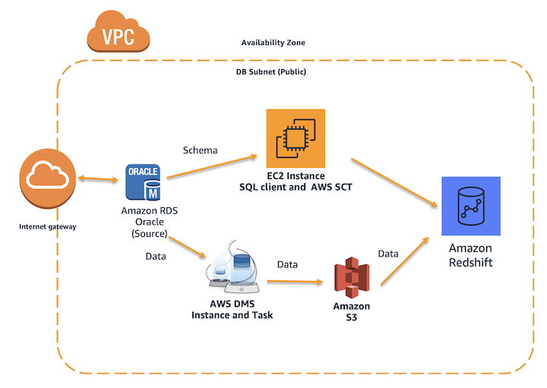

## [Before You Begin](https://catalog.us-east-1.prod.workshops.aws/v2/workshops/9f29cdba-66c0-445e-8cbb-28a092cb5ba7/en-US/lab11" \l "before-you-begin)

This lab assumes you have launched a Redshift cluster. If you have not launched a cluster, see [LAB 1 - Creating Redshift Clusters](https://catalog.us-east-1.prod.workshops.aws/v2/workshops/9f29cdba-66c0-445e-8cbb-28a092cb5ba7/en-US/lab1.html). The lab also assume you can gather the following information. If you have not configured your client tool, see [Lab 1 - Creating Redshift Clusters : Configure Client Tool](https://catalog.us-east-1.prod.workshops.aws/v2/workshops/9f29cdba-66c0-445e-8cbb-28a092cb5ba7/en-US/lab1.html#configure-client-tool).

If you deployed your cluster from [LAB 1 - Creating Redshift Clusters](https://catalog.us-east-1.prod.workshops.aws/v2/workshops/9f29cdba-66c0-445e-8cbb-28a092cb5ba7/en-US/lab1.html) and kept the default credentials, then use awsuser as the username and Awsuser123 as the password for your Redshift cluster.

* [Redshift-Endpoint]
* [Redshift-User]
* [Redshift-Password]
* [Redshift-Port]
* [Redshift-Database]
* [Redshift-Subnet]
* [Redshift-SecurityGroup]

Use the following CloudFormation template to deploy the Windows EC2 instance and AWS DMS replication instance required for this lab.

**Note: Labs 11, 12, and 18 use the same supplemental CloudFormation template. You can utilize the same issued resources interchangably for these labs.**

[Launch Stack](https://console.aws.amazon.com/cloudformation/home?#/stacks/new?stackName=ImmersionLab2&templateURL=https://s3-us-west-2.amazonaws.com/redshift-immersionday-labs/lab11.yaml)

When you launch the stack, you will have to configure your stack parameters. This will ensure that the DMS Instance and EC2 Instance have connectivity to your Redshift cluster.

* [RedshiftSecurityGroup] - sg-XXXXX
* [RedshiftSubnet] - subnet-XXXXX

Choose the [RedshiftSecurityGroup] that was launched by the Redshift cluster stack. For the [RedshiftSubnet] parameter, ensure you're selecting the two subnets with the 10.0.0.0/24 and 10.0.1.0/24 CIDR ranges.

If this stack is rolling back with a arn:aws:iam::XXX:role/dms-vpc-role is not configured properly error, go ahead and delete this template and re-launch it. It should deploy successfully the second time.

Make sure to launch this CloudFormation template in the US-West-2 or US-East-1 region.

The template will use the default CIDR block of 0.0.0.0/0 for the Windows EC2 instance Security Group which provides access from any IP Address. It is a best practice to restrict this with your IP address or a range of IP addresses which should have access.

Navigate to [AWS CloudFormation](https://console.aws.amazon.com/cloudformation/home) and click on your stack. Note down the EC2Hostname. You’ll need this parameter in subsequent steps.

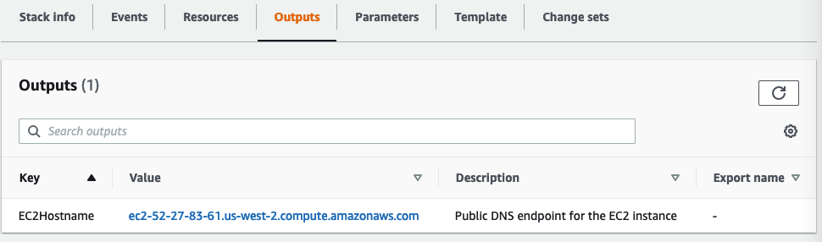

If you do not have a Remote Desktop client installed, you can use the instructions at this [link](https://docs.aws.amazon.com/AWSEC2/latest/WindowsGuide/connecting_to_windows_instance.html) to do so.

## [1. Convert the Schema](https://catalog.us-east-1.prod.workshops.aws/v2/workshops/9f29cdba-66c0-445e-8cbb-28a092cb5ba7/en-US/lab11" \l "1.-convert-the-schema)

In this section, you'll take care of migrating code and data structures from the source Oracle database to Amazon Redshift data warehouse using AWS Schema Conversion Tool. This include the table definitions, stored procedures, views and other database objects.

1.1. To start with the migration, first you'll need to login to the Windows EC2 instance using it's IP address or public endpoint. The CloudFormation template that you launched earlier deployed a Windows instance pre-loaded with the required drivers and softwares needed for this lab, i.e. AWS Schema Conversion Tool, SQL Workbench, and Oracle SQL Developer. You may use Windows Remote Desktop client (RDP) tool to login to that instance. Assume that to be your Windows workstation, where you do all your work on day to day basis.

Remember: You must replace the values between any <> with the values from the CloudFormation outputs tab. Values between any [] indicate parameters that you can receive by navigating to the specific AWS service within the console.

Remote Desktop Host: <EC2Hostname>

Username: developer

Password: Password1

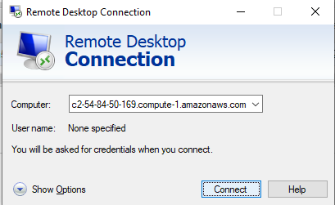

1.2. Once logged in, open AWS Schema Conversion Tool and initiate a new project.

Click File > New project. Then, select Data Warehouse (OLAP), Oracle DW as the source database engine, and Amazon Redshift as the target database engine. Click OK to continue.

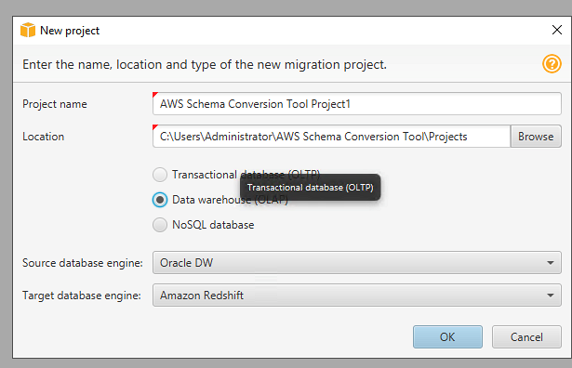

1.3. Now, you need to configure the connectivity for the Oracle source system.

Click Connect to Oracle DW, then input the parameters below and click Test. It should show that the connection is successful.

ServerName: localhost

port: 1521

SID: XE

Username: dms_user

Password: dms_user

DriverPath: C:\DMS Workshop\JDBC\ojdbc8.jar

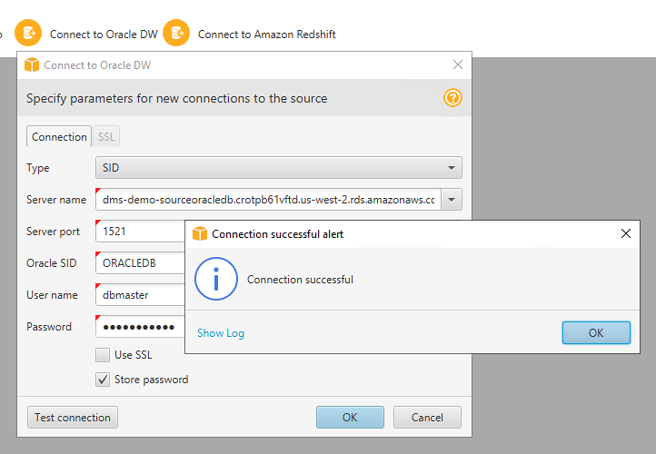

1.4. By default, AWS SCT uses AWS Glue as ETL solution for the migration. You will need to disable it as it's not being used in this lab.

Click Settings and then select Project Settings.

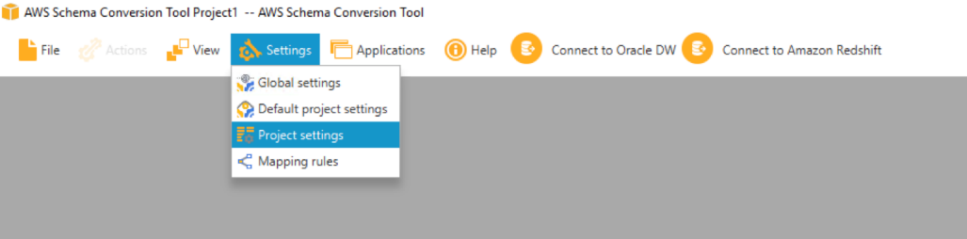

Uncheck Use AWS Glue.  
Click OK after that.

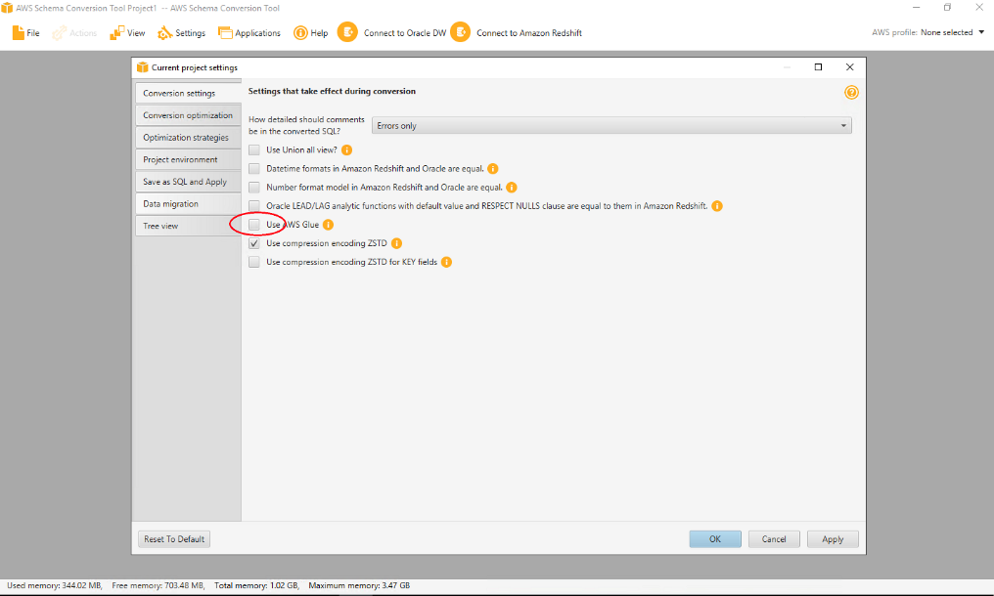

1.5. Now, you need to configure the connectivity for the target system, Redshift. Click Connect to Amazon Redshift. Input below parameters in the connection tab and then click Test. It should show that the connection is successful.

ServerName: [Redshift-Endpoint]

Port: [Redshift-Port]

Database: [Redshift-Database]

Username: [Redshift-User]

Password: [Redshift-Password]

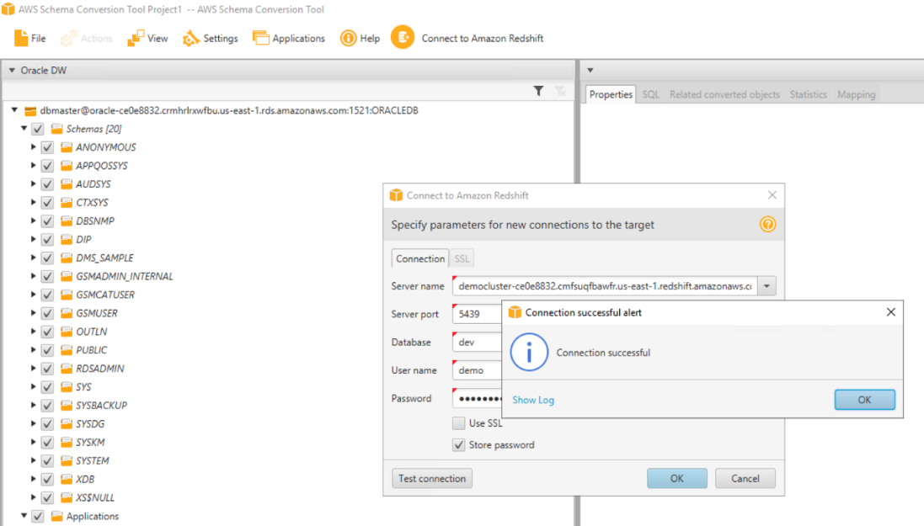

1.6. On the left hand side, you can see all objects in Oracle and on the right hand side, you can see all the Redshift objects. You can now convert the Oracle schema DMS_SAMPLE.

Right click DMS_SAMPLE schema and then click Convert schema.

After that, click the default options Yes and Continue when prompted on the next screens about existing objects and source database statistics.

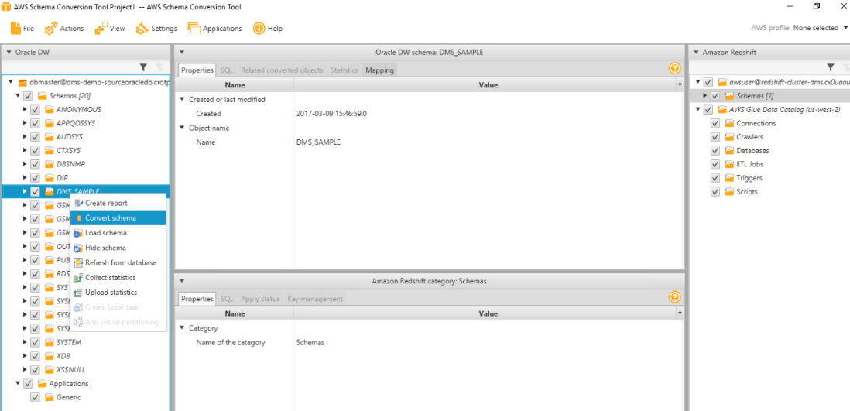

1.7. All Oracle objects should have gotten converted to Redshift syntax by now. But there would be some objects showing in Red, which essentially means that SCT couldn't fully migrate these objects. You can view an assessment summary for the migration to analyze those objects.

Click View > Assessment Report View

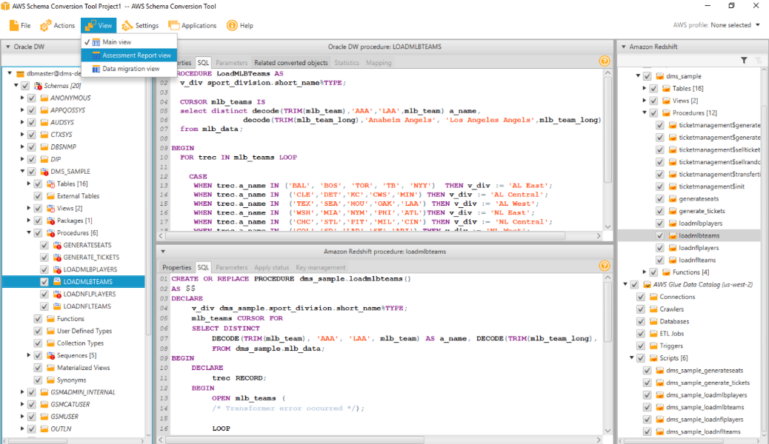

1.8. AWS SCT produces an executive summary describing the overall migration effort. It describes which objects could and couldn’t be migrated successfully using AWS SCT.  
Click Action Items tab, which would show what action you need to take to migrate the unsuccessful objects.

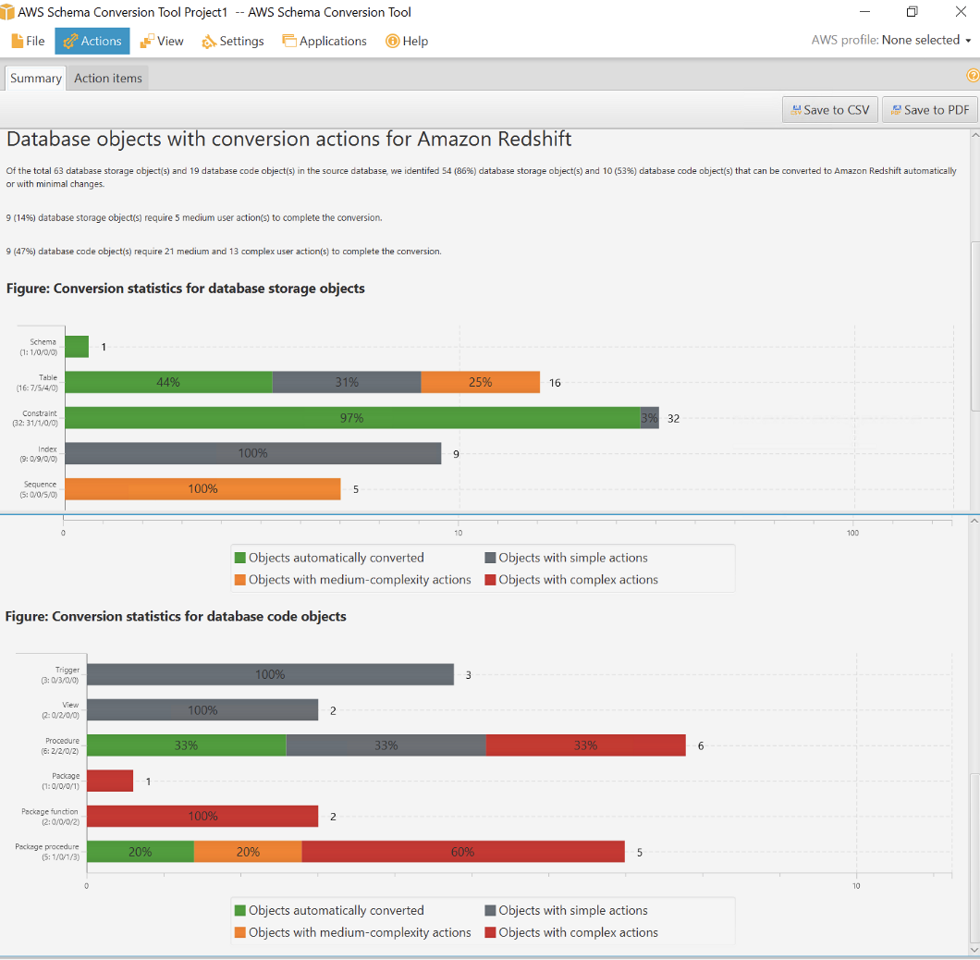

1.9. You may now examine stored procedure migration by this process.  
From the left hand screen, select the first stored procedure GENERATESEATS, which shows Oracle/Redshift code side by side and also highlights all code that could not be migrated. On the top action items screen, you can also see the automated recommendations on how to resolve these code migrations.

You can see that PL/SQL tables were used in this code, which is a vendor specific code and, hence, SCT could not convert it properly. Hypothetically, you would need to manually fix the code based on the business requirements of this stored procedure.

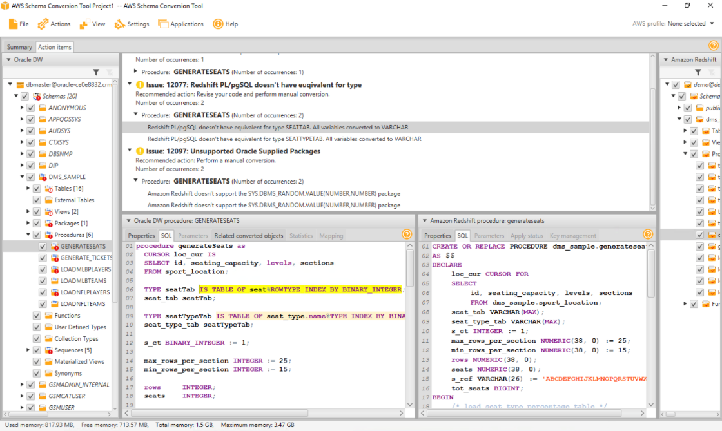

1.10. Now to save the successfully migrated objects in Redshift, right click dms_sample on the right hand side of the screen and click Apply to database. This will create all these structures in Redshift side, including table definitions, views, stored procedures and other objects. Click the default options Yes when prompted on the next screens. This process should run for a few seconds.

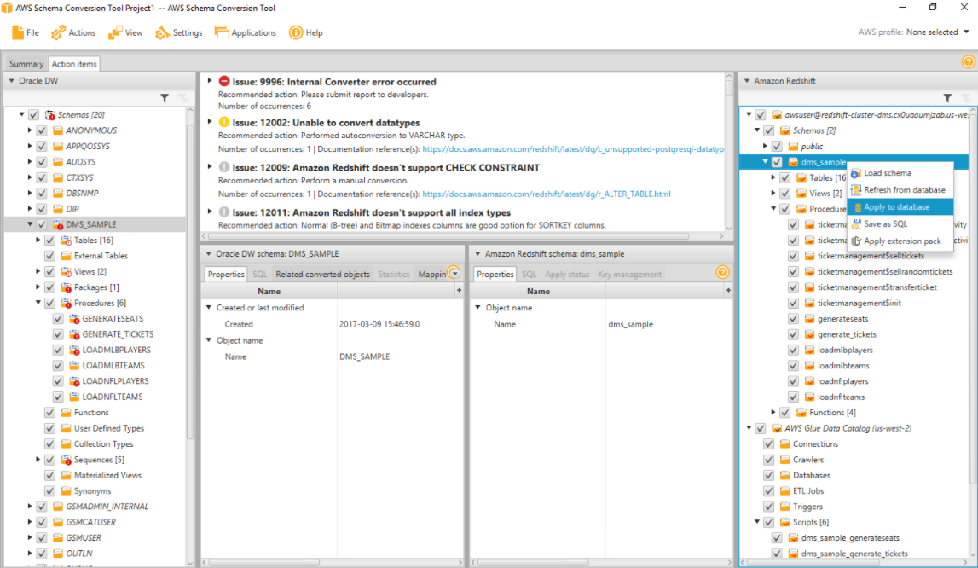

1.11. Now, lets verify these objects. You can use the Redshift query editor in the AWS console or a third party IDE like SQL Workbench, which is an open source JDBC IDE.  
Open SQL Workbench/J from the taskbar shortcut, which opens the new connection window. Ensure Amazon Redshift is the default group. Input the parameters below and then click Test, which should be successful. Then, click OK.

Driver: Amazon Redshift

URL: jdbc:redshift://[Redshift-Endpoint]:[Redshift-Port]/[Redshift-Database]

Username: [Redshift-User]

Password: [Redshift-Password]

Autocommit: tick mark

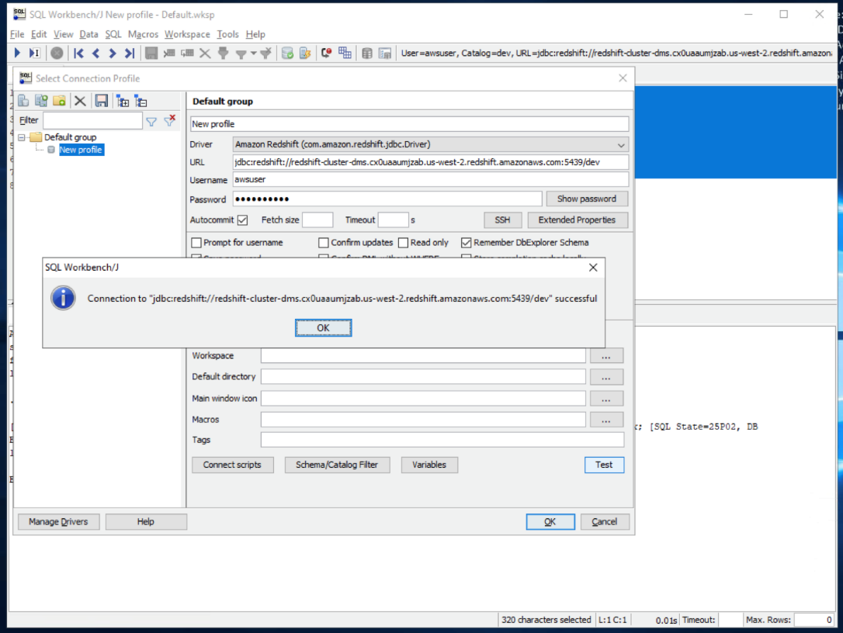

1.12. You may now examine the tables migrated to the dms_sample schema by running below query in SQL Workbench/J:

select t.table_schema, t.table_name,i.tbl_rows

from svv_tables t left join svv_table_info i

on t.table_schema = i.schema and t.table_name = i.table

where t.table_type = 'BASE TABLE' and t.table_schema='dms_sample'

order by 1,2

All these tables should have successfully been created in this Redshift schema, but as expected, there would not be any records in them. Next, you will migrate data from Oracle to Redshift using a service called AWS Database Migration Service (DMS).

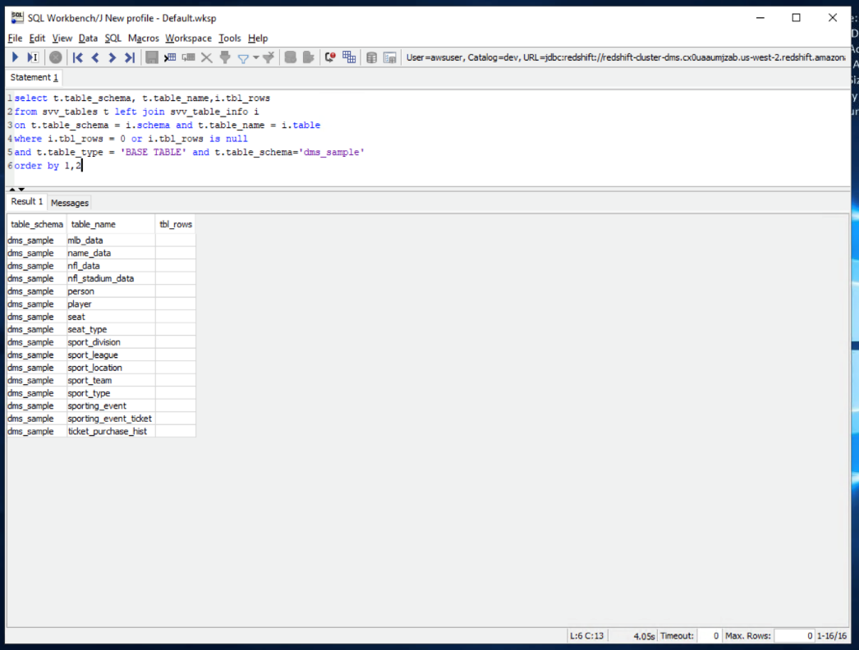

1.13. Before that, lets connect to Oracle and verify the dataset. Open Oracle SQL Developer from the taskbar shortcut (named sqldeveloper) and click the new connection button on the top left-hand side. Input below parameters:

Input the parameters below:

name: Oracle

username: dms_user

password: dms_user

hostname: localhost

port: 1521

sid: xe

Click Test, which should show the status as Success. Click Connect and input above password if you are prompted again.

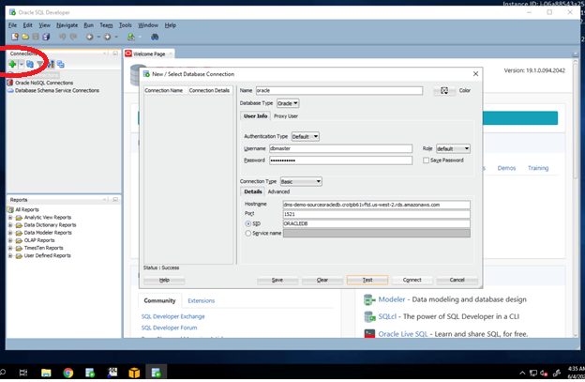

1.14. Let us check these tables in Oracle using Oracle SQL Developer. Open Oracle SQL Developer and execute this query:

select owner, table_name, nvl(num_rows,-1)

from all_tables where owner='DMS_SAMPLE'

order by 1,2

You can see decent amount of records for this ticketing dataset. To migrate these records, you’ll be using AWS Database Migration Service (DMS).

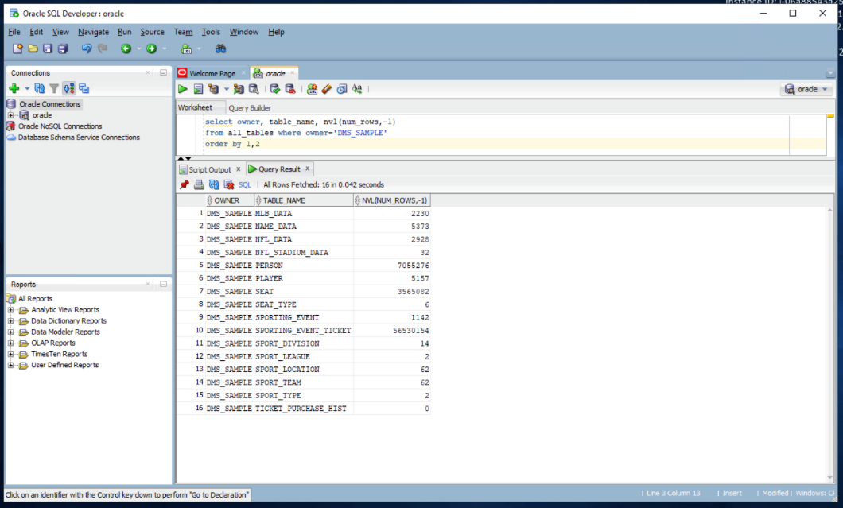

### [2. Migrate the data](https://catalog.us-east-1.prod.workshops.aws/v2/workshops/9f29cdba-66c0-445e-8cbb-28a092cb5ba7/en-US/lab11" \l "2.-migrate-the-data)

In this section, you'll take care of migrating data from the source Oracle database to Amazon Redshift data warehouse using AWS Database Migration Service (DMS).

2.1. Open your web browser and login to the AWS console. Navigate to DMS Service. For DMS, you would first need to create a replication instance with a suitable configuration. This replication instance would take care of all replication tasks from source to target databases. If you navigate to Replication instances, you can see an instance that was taken care by our initial CloudFormation template for this demo.

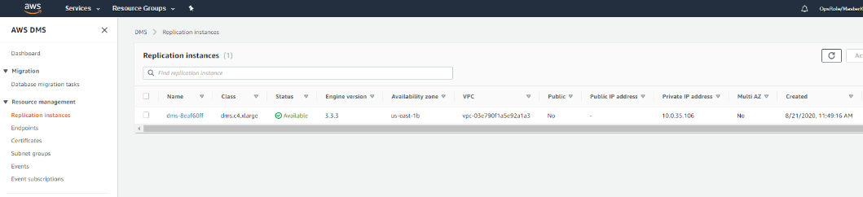

2.2. Next, you need to configure the source and target endpoints. Click Endpoints and create Create endpoint

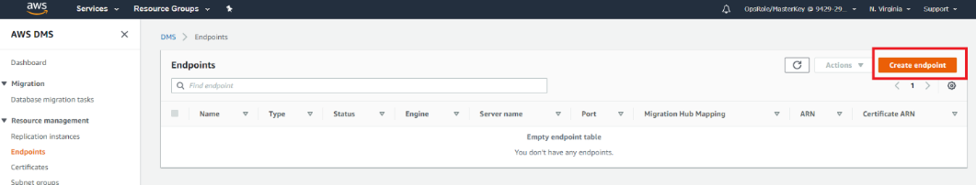

2.3. First, you'll configure a source endpoint for Oracle. If you tickmark Select RDS DB instance, DMS automatically finds out our Oracle RDS instance, which you can select. However, our Oracle DB is located in a different environment so leave this unchecked.

Make sure the Source endpoint box is checked. Enter a relevant name under the Endpoint identifier text box. Then, choose Oracle for the Source engine. Another dialogue should appear named Access to endpoint database. Choose Provide access information manually.

Next, lets pre-fill some of the Oracle DB server details.

ServerName: <EC2Hostname>

Port: 1521

UserName: dms_user

Password: dms_user

SID: xe

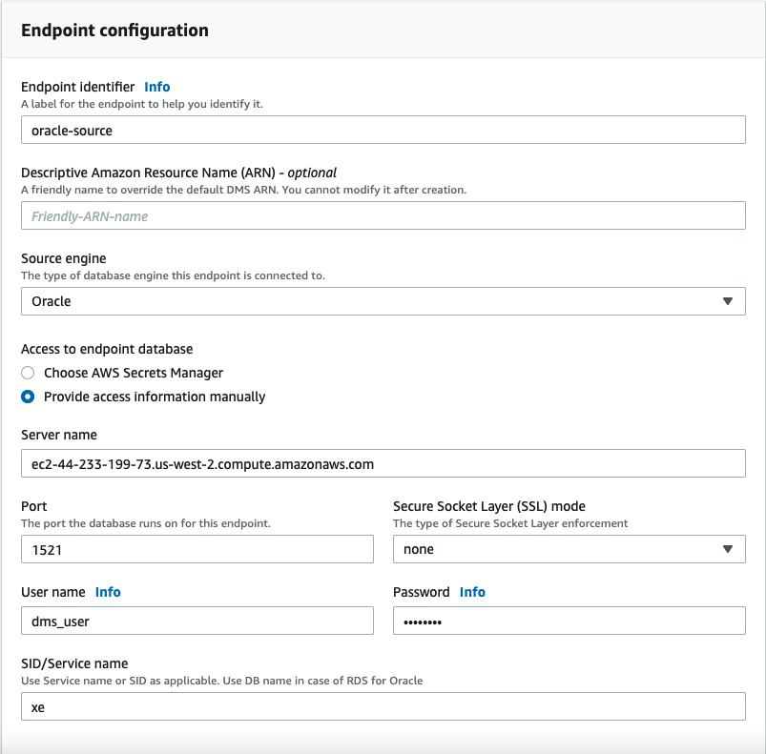

2.4. You'll expand the option Test endpoint connection (optional) option and select the generated VPC and then click Run test. Once the test is successful, click Create endpoint.

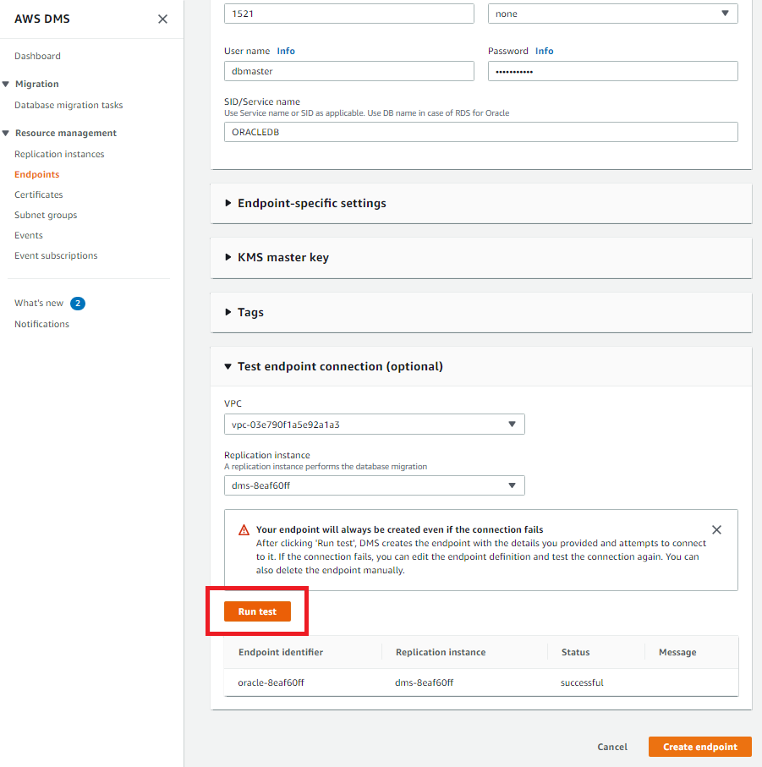

2.5. Next, you'll configure a target endpoint for Redshift.

Make sure the Target endpoint box is checked. Enter a relevant name under the Endpoint identifier text box. Then, choose Amazon Redshift for the Target engine. Another dialogue should appear named Access to endpoint database. Choose Provide access information manually. Please input below:

ServerName: [Redshift-Endpoint]

Port: [Redshift-Port]

UserName: [Redshift-User]

Password: [Redshift-Password]

DatabaseName: [Redshift-Database]

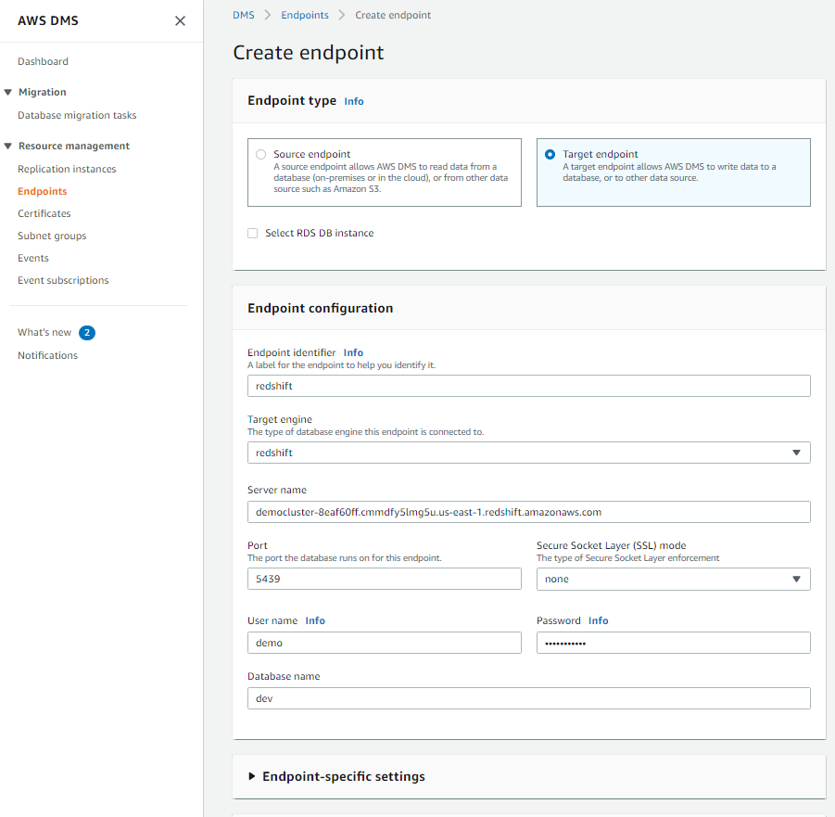

You'll expand the option Test endpoint connection option and select the generated VPC and then click Run test. Once the test is successful, click Create endpoint.

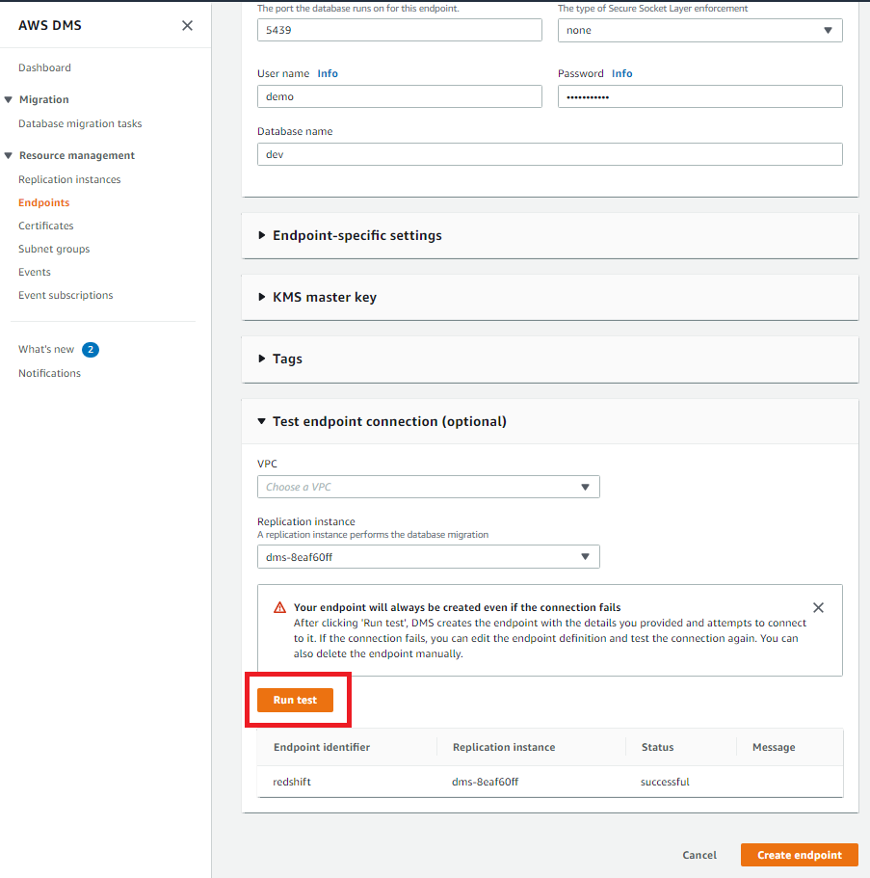

You can now see both our source and target endpoints.

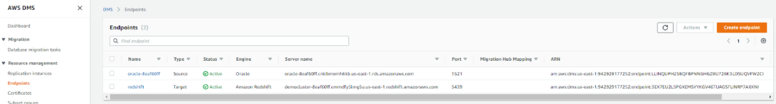

2.6. Our last configuration step is to create a replication task, which will take care of the data migration. Navigate to Database migration tasks and click Create Task.

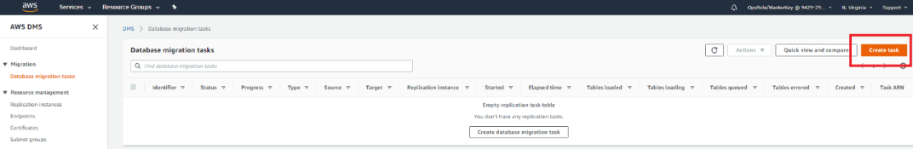

You need to privide any meaningful name in the Task identifier field. Select the DMS replication instance that was generated by the CloudFormation template. Then, select the source and target endpoints you created in the previous steps. For the option Migration type, click Migrate existing data and replicate existing changes.

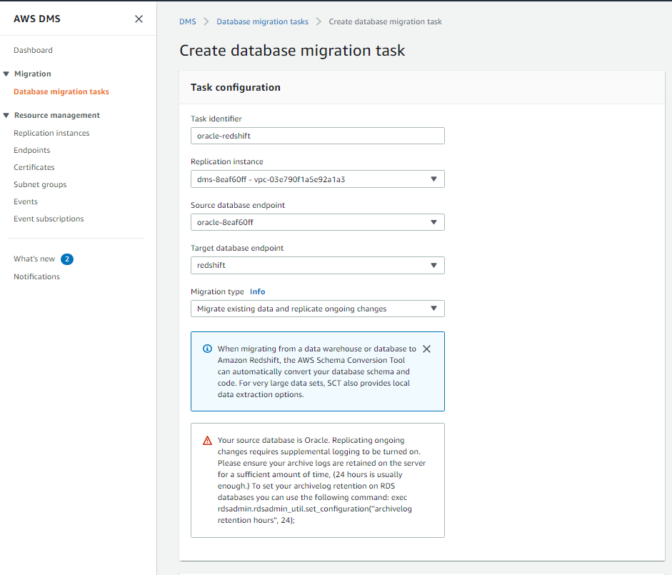

Next, under Task settings, you'll go with all default options except for Target table preparation mode, where you will need to select Do nothing as you already created all tables using AWS Schema conversion tool earlier.  
Also, tick Enable CloudWatch logs to view DMS logs in case something going wrong.

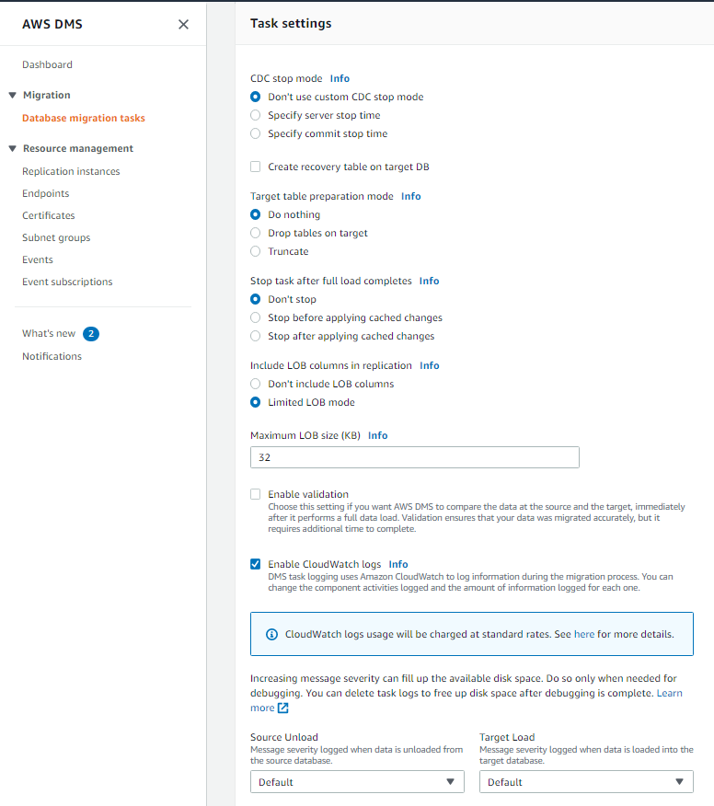

For the next section under Table mappings, click JSON editor. Paste in the code below:

{

"rules": [

{

"rule-type": "selection",

"rule-id": "1",

"rule-name": "1",

"object-locator": {

"schema-name": "DMS_SAMPLE%",

"table-name": "%"

},

"rule-action": "include",

"filters": []

}

]

}

Click Save followed by Create task on the bottom of the page.

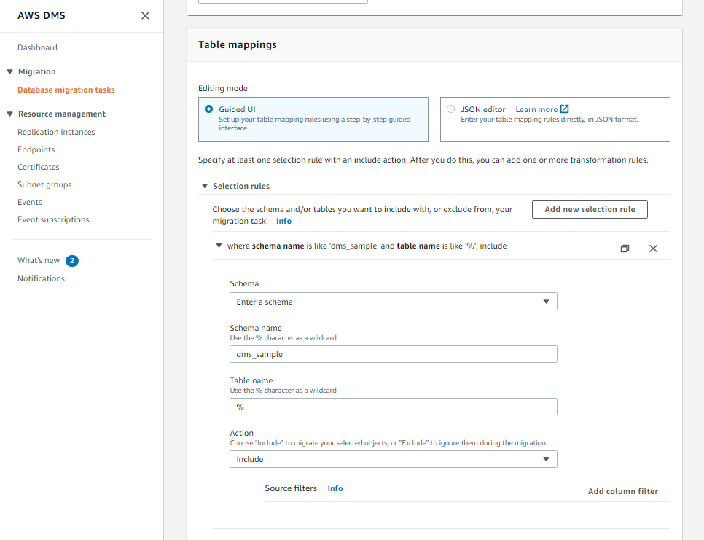

2.7. Now, you will run the migration, which will migrate all existing data from Oracle to Redshift and then also take care of Change data capture (CDC) to cater ongoing changes.  
Select the replication task and follow through with Action > Restart/Resume once the creation process is complete.

If the DMS replication task is failing, you may have missed any of the steps above.

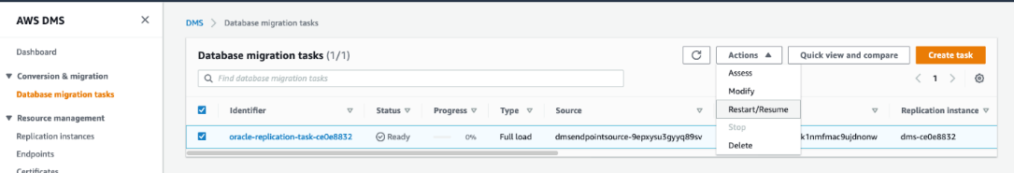

If you want to view the statistics of what data is getting transferred, you can go to the summary page, which allows you to view the statistics of how many records are getting transferred via DMS.

Click full load task and click Table statistics.

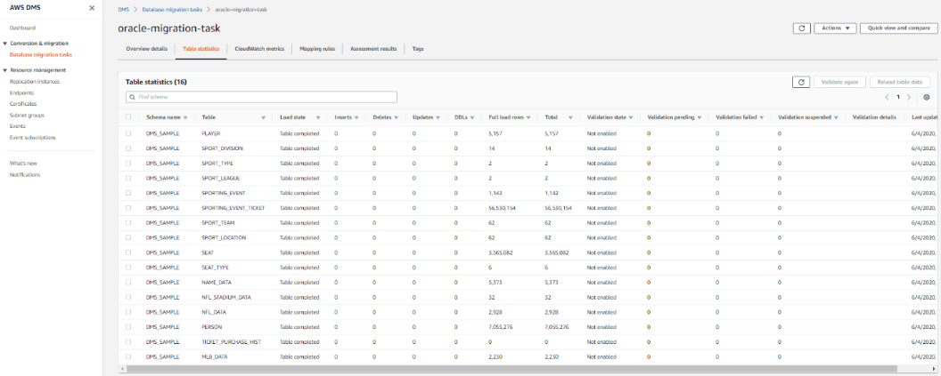

2.8. You can verify the same in SQL Workbench. You can see all these tables got loaded with data in Redshift.  
Execute the same command executed earlier in SQL Workbench to view the record count.

select t.table_schema, t.table_name,i.tbl_rows

from svv_tables t left join svv_table_info i

on t.table_schema = i.schema and t.table_name = i.table

where t.table_type = 'BASE TABLE' and t.table_schema='dms_sample'

order by 1,2

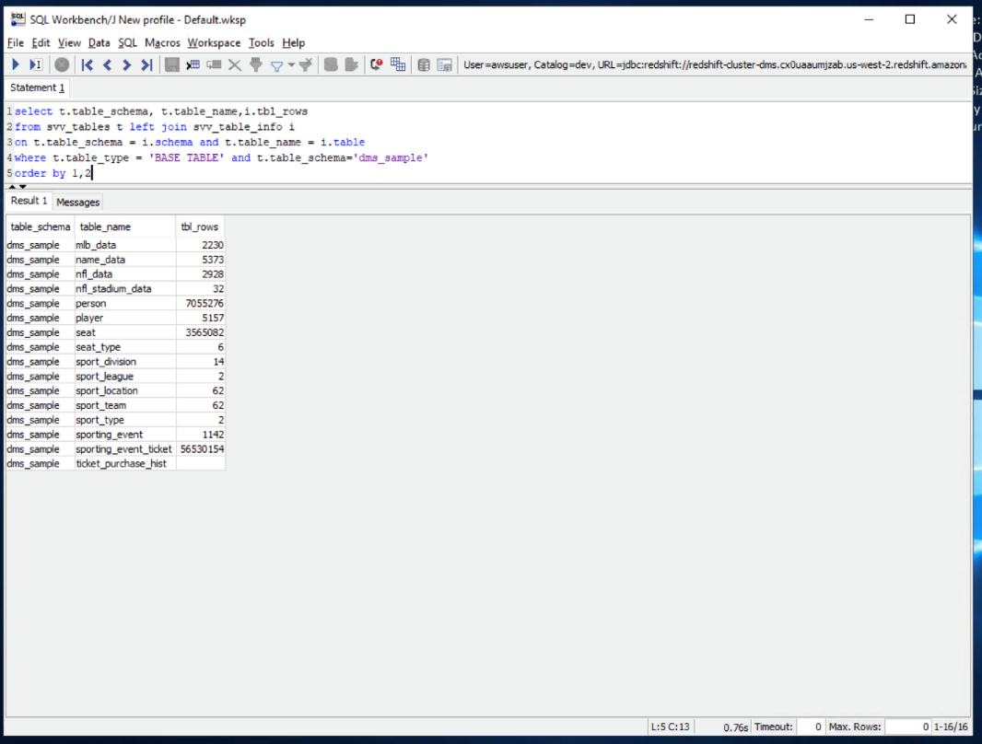

## [3. Keep the data in sync](https://catalog.us-east-1.prod.workshops.aws/v2/workshops/9f29cdba-66c0-445e-8cbb-28a092cb5ba7/en-US/lab11" \l "3.-keep-the-data-in-sync)

Now, you will verify the Change Data Capture (CDC) functionality of DMS to make sure ongoing changes are automatically replicated from Oracle to Redshift.

3.1. In our dataaset, you have a table sport_type with just 2 records in it. You will now insert some records on the Oracle side to verify if that gets replicated to Redshift. Execute the command below in SQL Workbench/J to view all records in sport_type table.

1

select * from dms_sample.sport_type order by 1;

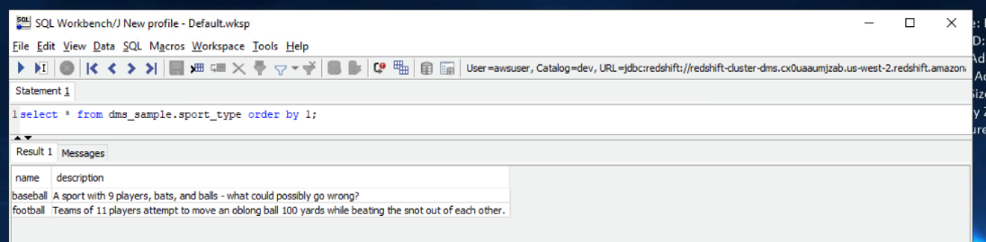

3.2. You may view data on this table in Oracle too, which should show the same 2 records. Switch to Oracle SQL Developer and execute the command below to view the sport_type table.

select * from dms_sample.sport_type order by 1;

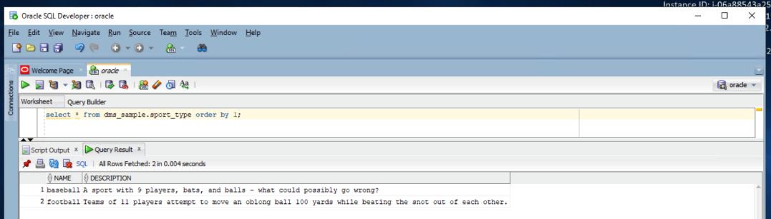

3.3. You want to confirm that the CDC process is operational. For that, you will insert some records in the sport_type table in Oracle. Execute the command below in Oracle SQL Developer to insert five records in sport_type table

INSERT ALL

INTO dms_sample.sport_type (name,description) VALUES ('hockey', 'A sport in which two teams play against each other by trying to more a puck into the opponents goal using a hockey stick')

INTO dms_sample.sport_type (name,description) VALUES ('basketball', 'A sport in which two teams of five players each that oppose one another shoot a basketball through the defenders hoop')

INTO dms_sample.sport_type (name,description) VALUES ('soccer','A sport played with a spherical ball between two teams of eleven players')

INTO dms_sample.sport_type (name,description) VALUES ('volleyball','two teams of six players are separated by a net and each team tries to score by grounding a ball on the others court')

INTO dms_sample.sport_type (name,description) VALUES ('cricket','A bat-and-ball game between two teams of eleven players on a field with a wicket at each end')

SELECT * FROM dual;

COMMIT;

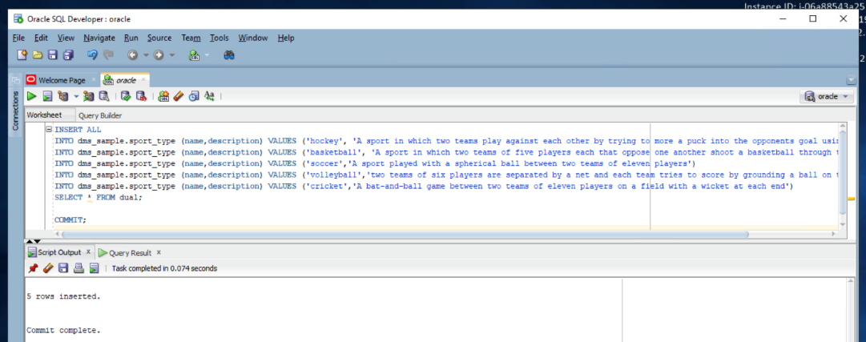

3.4. Execute the command below in Oracle SQL Developer to view these new records sport_type table.

select * from dms_sample.sport_type order by 1;

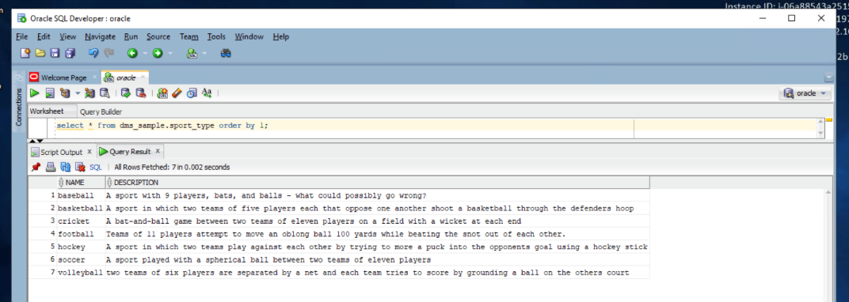

3.5. Now, you'll go back to Redshift and see the records there. Execute below command in SQL workbench to view the sport_type table.

1

select * from dms_sample.sport_type order by 1;

You should see the seven newly inserted records there too.

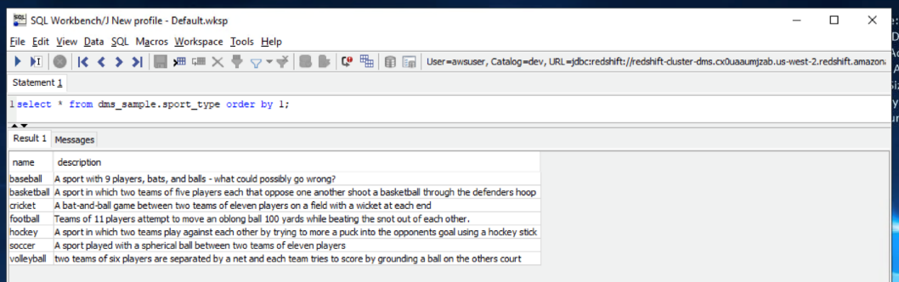

3.6. You can view the logs of the CDC process to see a nice tabular metrics in the DMS console.  
Navigate to DMS service in AWS console and Select the Ongoing Replication task and click Table statistics.

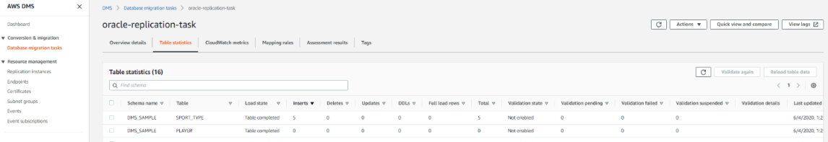

## [Before You Leave](https://catalog.us-east-1.prod.workshops.aws/v2/workshops/9f29cdba-66c0-445e-8cbb-28a092cb5ba7/en-US/lab11" \l "before-you-leave)

If you are done using your lab environment, please consider decommissioning it to avoid having to pay for unused resources. Moreover, make sure to delete DMS endpoints, replication task(s), and DMS instance prior to deleting your CloudFormation template. If you plan on doing Lab 12 or Lab 18, you can leave this CloudFormation stack running as both of those labs reference these same resources.

# 12. SQL Server to Redshift Migration

This lab demonstrates how we can use AWS Schema Conversion Tool (AWS SCT) to migrate data and code (DDL structures and the T-SQL code) from an SQL Server database to Amazon Redshift.

## [Contents](https://catalog.us-east-1.prod.workshops.aws/v2/workshops/9f29cdba-66c0-445e-8cbb-28a092cb5ba7/en-US/lab12" \l "contents)

* [Architecture](https://catalog.us-east-1.prod.workshops.aws/v2/workshops/9f29cdba-66c0-445e-8cbb-28a092cb5ba7/en-US/lab12#architecture)
* [Before you Begin](https://catalog.us-east-1.prod.workshops.aws/v2/workshops/9f29cdba-66c0-445e-8cbb-28a092cb5ba7/en-US/lab12#before-you-begin)
* [1. Convert the Schema](https://catalog.us-east-1.prod.workshops.aws/v2/workshops/9f29cdba-66c0-445e-8cbb-28a092cb5ba7/en-US/lab12#2-convert-the-schema)
* [2. Migrate the data](https://catalog.us-east-1.prod.workshops.aws/v2/workshops/9f29cdba-66c0-445e-8cbb-28a092cb5ba7/en-US/lab12#3-migrate-the-data)
* [Before You Leave](https://catalog.us-east-1.prod.workshops.aws/v2/workshops/9f29cdba-66c0-445e-8cbb-28a092cb5ba7/en-US/lab12#before-you-leave)

## [Architecture](https://catalog.us-east-1.prod.workshops.aws/v2/workshops/9f29cdba-66c0-445e-8cbb-28a092cb5ba7/en-US/lab12" \l "architecture)

To solve the challenge, here is the architecture that you would be going through in this lab:

* Amazon Redshift cluster: This will be the target database for this migration lab
* Windows EC2 instance: This windows instance will serve as our workstation, where you'll have all software and tools installed including a sample Oracle DB and MS SQL Server DB.
* AWS DMS replication instance: This instance will take care of migrating data from source to target databases



## [Before You Begin](https://catalog.us-east-1.prod.workshops.aws/v2/workshops/9f29cdba-66c0-445e-8cbb-28a092cb5ba7/en-US/lab12" \l "before-you-begin)

This lab assumes you have launched a Redshift cluster. If you have not launched a cluster, see [LAB 1 - Creating Redshift Clusters](https://catalog.us-east-1.prod.workshops.aws/v2/workshops/9f29cdba-66c0-445e-8cbb-28a092cb5ba7/en-US/lab1.html). The lab also assume you can gather the following information. If you have not configured your client tool, see [Lab 1 - Creating Redshift Clusters : Configure Client Tool](https://catalog.us-east-1.prod.workshops.aws/v2/workshops/9f29cdba-66c0-445e-8cbb-28a092cb5ba7/en-US/lab1.html#configure-client-tool).

If you deployed your cluster from [LAB 1 - Creating Redshift Clusters](https://catalog.us-east-1.prod.workshops.aws/v2/workshops/9f29cdba-66c0-445e-8cbb-28a092cb5ba7/en-US/lab1.html) and kept the default credentials, then use awsuser as the username and Awsuser123 as the password for your Redshift cluster.

* [Redshift-Endpoint]
* [Redshift-User]
* [Redshift-Password]
* [Redshift-Port]
* [Redshift-Database]
* [Redshift-Subnet]
* [Redshift-SecurityGroup]

Use the following CloudFormation template to deploy the Windows EC2 instance and AWS DMS replication instance required for this lab.

**Note: Labs 11, 12, and 18 use the same supplemental CloudFormation template. You can utilize the same issued resources interchangably for these labs.**

[Launch Stack](https://console.aws.amazon.com/cloudformation/home?#/stacks/new?stackName=ImmersionLab2&templateURL=https://s3-us-west-2.amazonaws.com/redshift-immersionday-labs/lab11.yaml)

When you launch the stack, you will have to configure your stack parameters. This will ensure that the DMS Instance and EC2 Instance have connectivity to your Redshift cluster.

* [RedshiftSecurityGroup] - sg-XXXXX
* [RedshiftSubnet] - subnet-XXXXX

Choose the [RedshiftSecurityGroup] that was launched by the Redshift cluster stack. For the [RedshiftSubnet] parameter, ensure you're selecting the two subnets with the 10.0.0.0/24 and 10.0.1.0/24 CIDR ranges.

If this stack is rolling back with a arn:aws:iam::XXX:role/dms-vpc-role is not configured properly error, go ahead and delete this template and re-launch it. It should deploy successfully the second time.

Make sure to launch this CloudFormation template in the US-West-2 or US-East-1 region.

The template will use the default CIDR block of 0.0.0.0/0 for the Windows EC2 instance Security Group which provides access from any IP Address. It is a best practice to restrict this with your IP address or a range of IP addresses which should have access.

Navigate to [AWS CloudFormation](https://console.aws.amazon.com/cloudformation/home) and click on your stack. Note down the EC2Hostname. You’ll need this parameter in subsequent steps.



If you do not have a Remote Desktop client installed, you can use the instructions at this [link](https://docs.aws.amazon.com/AWSEC2/latest/WindowsGuide/connecting_to_windows_instance.html) to do so.

## [1. Convert the Schema](https://catalog.us-east-1.prod.workshops.aws/v2/workshops/9f29cdba-66c0-445e-8cbb-28a092cb5ba7/en-US/lab12" \l "1.-convert-the-schema)

In this section, you'll take care of migrating code and data structures from the source SQL Server database to Amazon Redshift datawarehouse using AWS Schema Conversion Tool. This include the table definitions, stored procedures, views and other database objects.

1.1. To start with the migration, first you'll need to login to the windows EC2 instance using it's IP address or public endpoint. You need to use Windows Remote Desktop client (RDP) tool to login to that instance. Assume that to be your windows workstation, where you do all your work on day-to-day basis.

Remember: You must replace the values between any <> with the values from the CloudFormation outputs tab. Values between any [] indicate parameters that you can receive by navigating to the specific AWS service within the console.

Remote Desktop Host: <EC2HostName>

Username: developer

Passowrd: Password1



1.2. Once logged in, open AWS Schema Conversion Tool and initiate a new project.

Click File > New project. Then, select Data Warehouse (OLAP), Microsoft SQL Server DW as the source database engine, and Amazon Redshift as the target database engine. Click OK to continue.

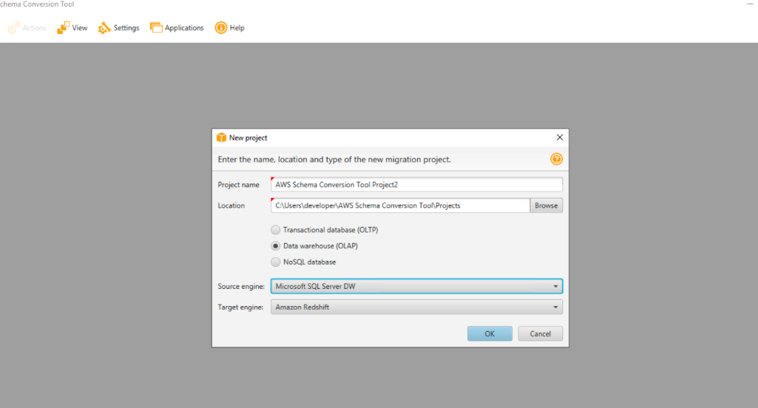

1.3. Now, you need to configure the connectivity for the Microsoft SQL Server source system.

Click Connect to Microsoft SQL Server DW, and then input the parameters below and click Test. It should show that the connection is successful. Leave Instance name as blank.

Servername: localhost

port: 1433

Username: awssct

Password: Password1

DriverPath: C:\DMS Workshop\JDBC\sqljdbc_7.4\enu\mssql-jdbc-7.4.1.jre8.jar

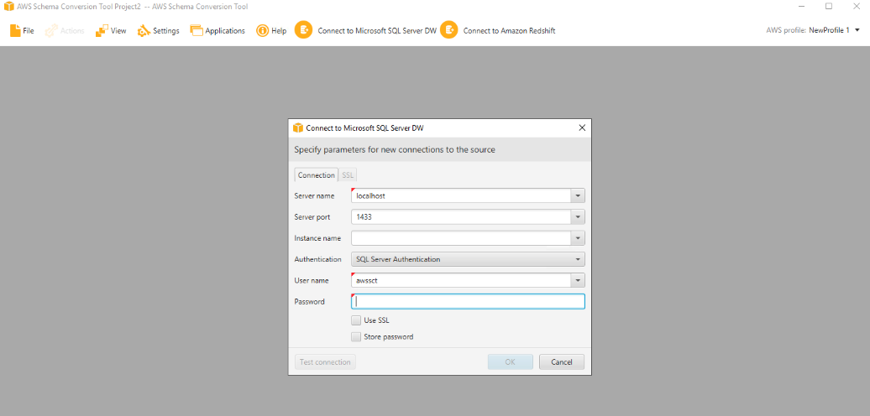

1.4. Now, you need to configure the connectivity for the target system: Redshift. Input the parameters below in the connection tab and then click Test. It should show that the connection is successful.

ServerName: [Redshift-Endpoint]

Port: [Redshift-Port]

Database: [Redshift-Database]

Username: [Redshift-User]

Password: [Redshift-Password]

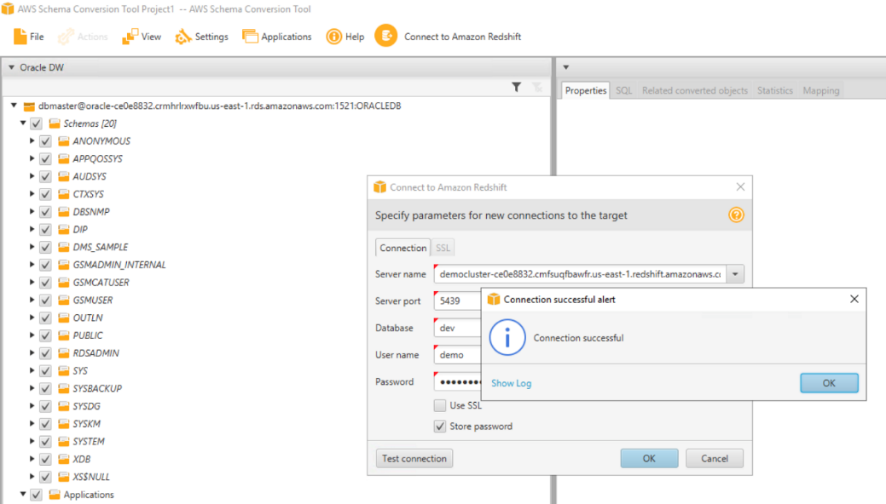

1.5. On the left hand side, you can see all objects in SQL Server and on the right hand side, you can see all the Redshift objects. You can now convert the SQL Server schema DMS_SAMPLE.

Right click on the DMS_SAMPLE schema and then click Convert schema.

After that, click the default options Yes and Continue when prompted on the next screens about existing objects and source database statistics.

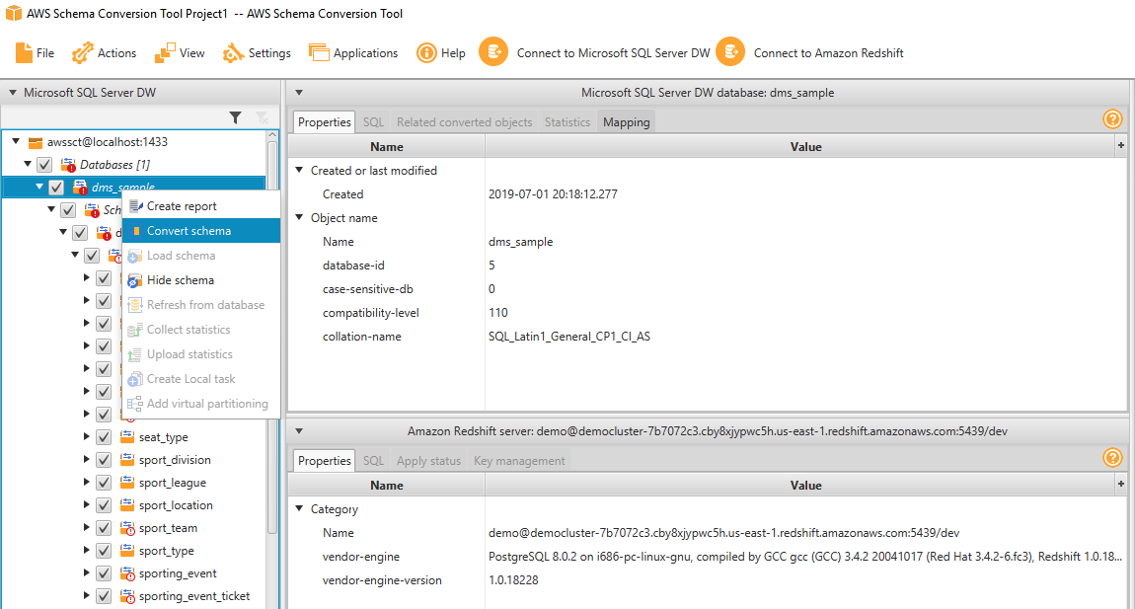

1.6. All SQL Server objects should have gotten converted to Redshift syntax by now. There will be some objects showing in red. This means that SCT couldn’t fully migrate these objects. You can view an assessment summary for the migration to analyze these objects.

Click View > Assessment Report View.

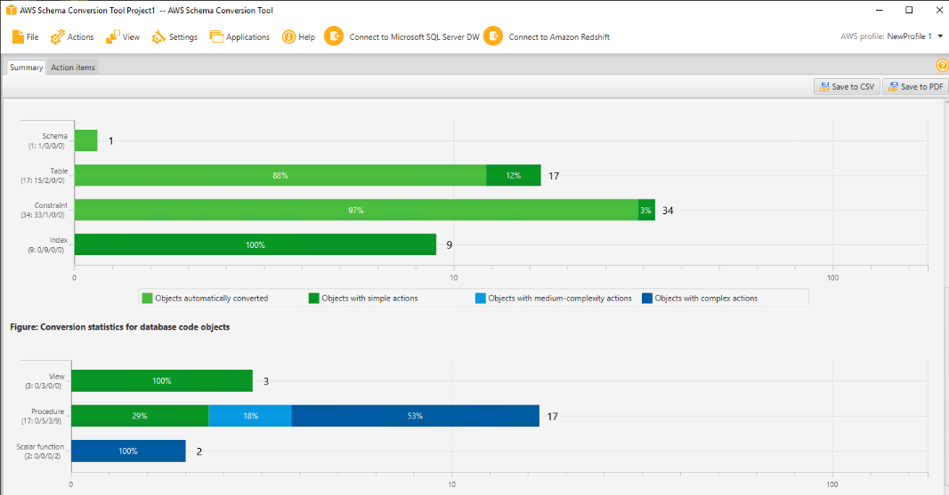

1.7. AWS SCT produces an executive summary describing the overall migration effort. It describes which objects could and couldn’t be migrated successfully using AWS SCT.

Click on the Action Items tab, which would show what action you need to take to migrate the unsuccessful objects.

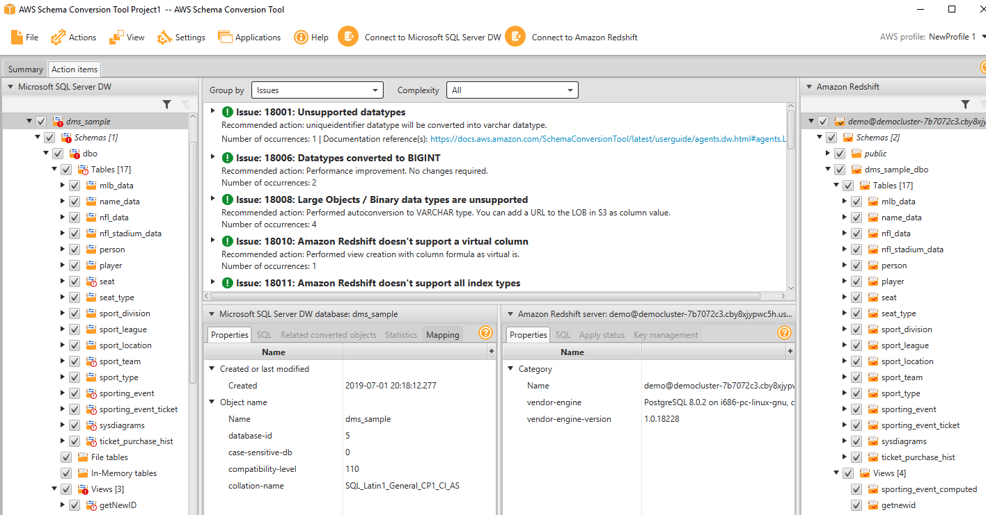

1.8. Now, to save the successfully migrated objects in Redshift, you can save the scripts generated by SCT into your local disk and run these scripts directly into your Redshift cluster using SQL Workbench. SCT automatically adds the database name to the target schema, hence, you can see dms_sample_dbo as the newly generated schema on the right-hand (Redshift) side of SCT.

Right click dms_sample_dbo on the right-hand Redshift side of SCT and click Apply to database.

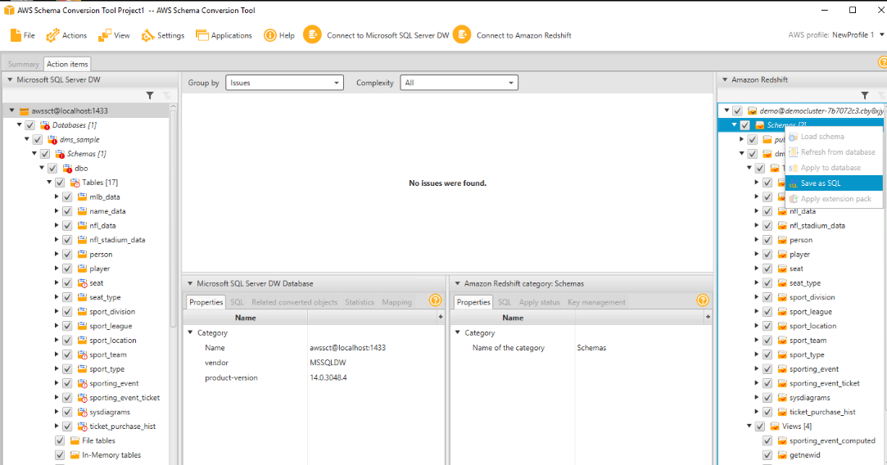

1.9. Now, lets verify these objects. You can use the Redshift query editor in the AWS console or a third party IDE like SQL Workbench, which is an open source JDBC IDE.

Open SQL Workbench/J from the taskbar shortcut, which opens the new connection window. Ensure Amazon Redshift is the default group.

Then move back to the connectivity screen. Input the parameters below and then click Test, which should be successful. Click OK to save the connection profile.

Driver: Amazon Redshift

URL: jdbc:redshift://[Redshift-Endpoint]:[Redshift-Port]/[Redshift-Database]

Username: [Redshift-User]

Password: [Redshift-Password]

Autocommit: tick mark

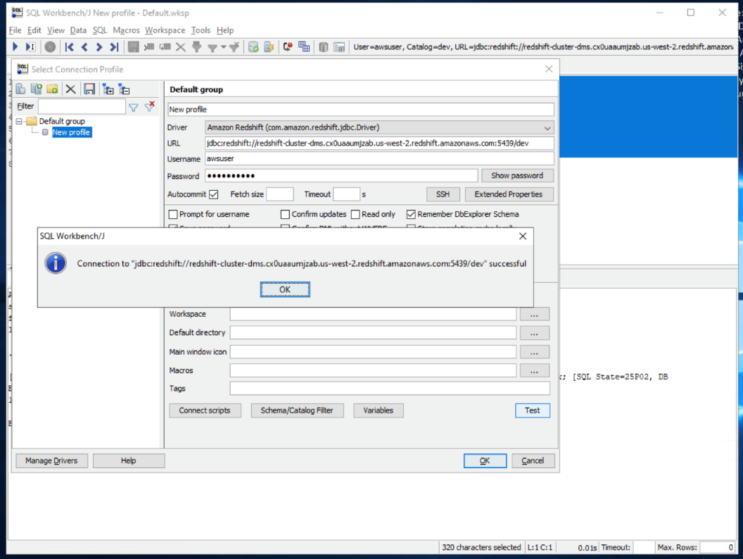

1.10. You can examine the tables migrated to the dms_sample_dbo schema by running below query in SQL Workbench/J:

select t.table_schema, t.table_name,i.tbl_rows

from svv_tables t left join svv_table_info i

on t.table_schema = i.schema and t.table_name = i.table

where t.table_type = 'BASE TABLE' and t.table_schema='dms_sample_dbo'

order by 1,2

All these tables should have successfully gotten created in this Redshift schema, but as expected, there would not be any records in them.

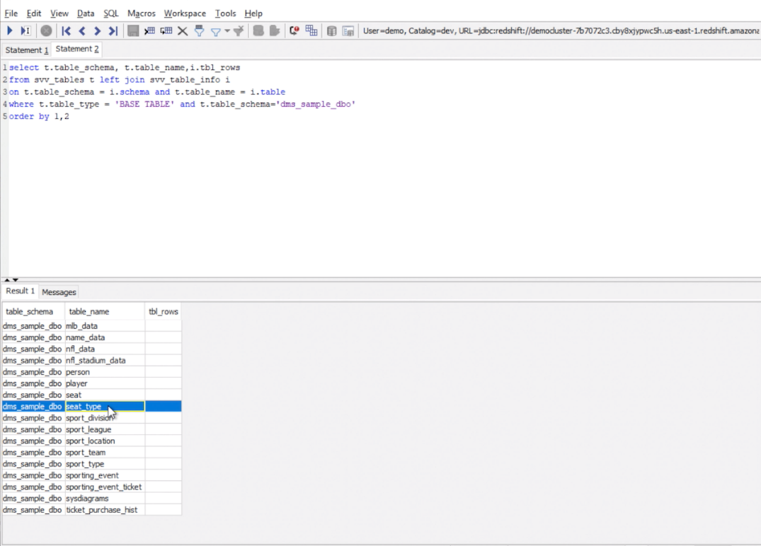

1.11. Now, open SQL Server Management Studio from the taskbar shortcut and click new connection button on left hand top side. Input the parameters below:

Server type: Database Engine

Server name: localhost

Authentication: Windows Authentication

Click Connect and then click on the New Query option.

Execute the query below:

use dms_sample;

SELECT SCHEMA_NAME(t.[schema_id]) AS [table_schema],

OBJECT_NAME(p.[object_id]) AS [table_name],SUM(p.[rows]) AS [row_count]

FROM [sys].[partitions] p

INNER JOIN [sys].[tables] t ON p.[object_id] = t.[object_id]

WHERE p.[index_id] < 2

GROUP BY p.[object_id],t.[schema_id]

ORDER BY 3

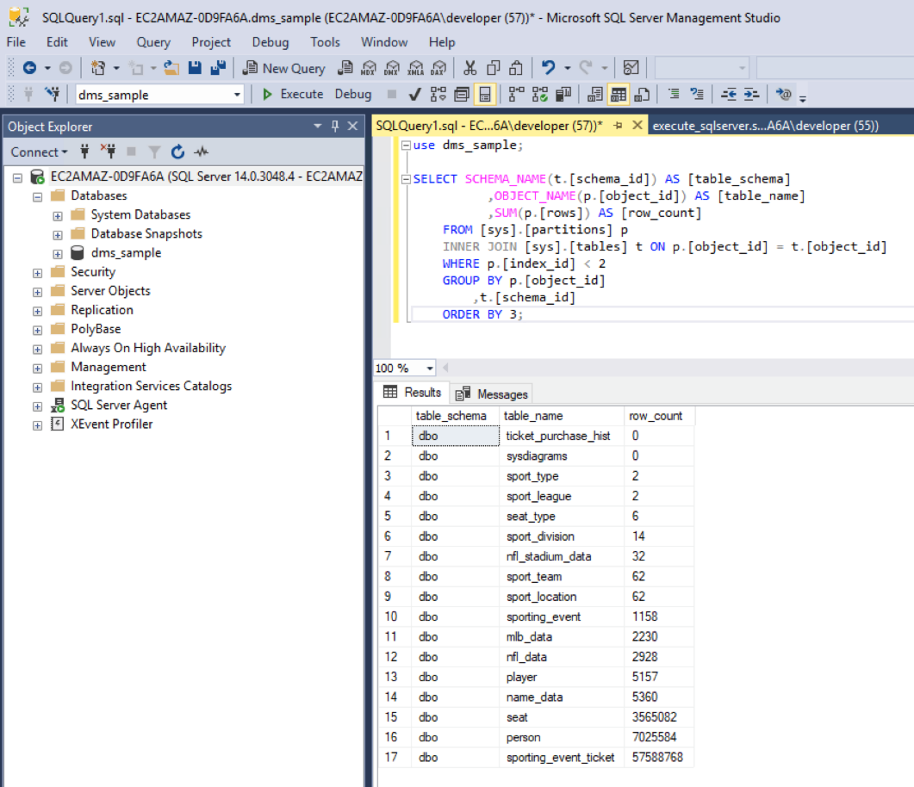

In SQL Server Management Studio, open the script from location C:\DMS Workshop\Scripts\execute_sqlserver.sql and click execute to enable MS Replication.

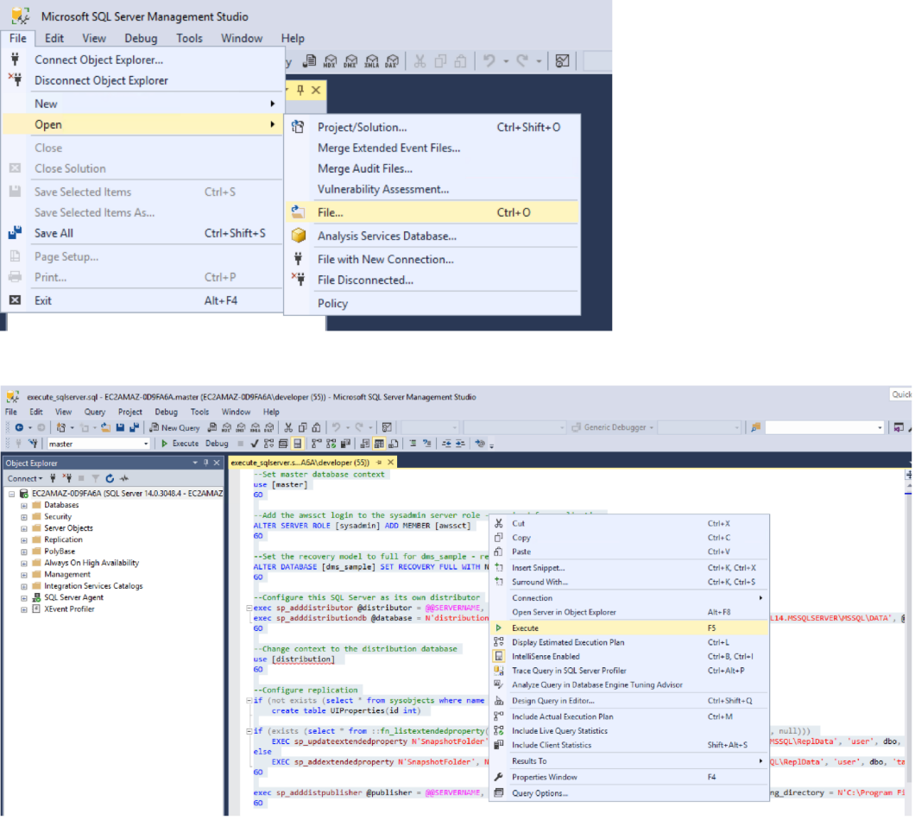

If you execute the script more than once, you may see an error, which you may safely ignore: The server is already defined as Distributor/Publisher.

Next, you will migrate data from SQL Server to Redshift using a service called AWS Database Migration Service (DMS).

### [2. Migrate the data](https://catalog.us-east-1.prod.workshops.aws/v2/workshops/9f29cdba-66c0-445e-8cbb-28a092cb5ba7/en-US/lab12" \l "2.-migrate-the-data)

In this section, you'll take care of migrating data from the source SQL Server database to Amazon Redshift data warehouse using AWS Database Migration Service (DMS). To prepare for the following steps with AWS DMS, a transformation rule was applied to add the prefix dms_sample on the schema name.

2.1. Open your web browser and login to the AWS console. Navigate to DMS Service. For DMS, you would first need to create a replication instance with a suitable configuration. This replication instance would take care of all replication tasks from source to target databases. If you navigate to Replication instances, you can see an instance that was taken care by our initial CloudFormation template for this demo.

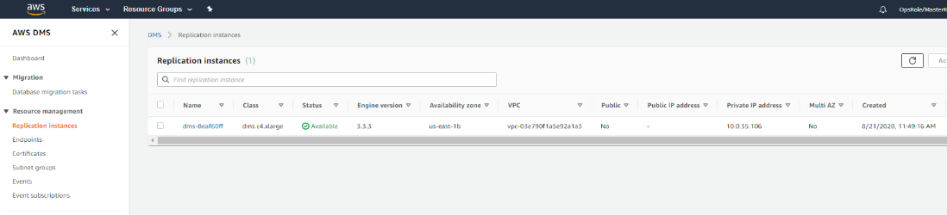

2.2. Next, you need to configure the source and target endpoints. Click Endpoints and create Create endpoint.

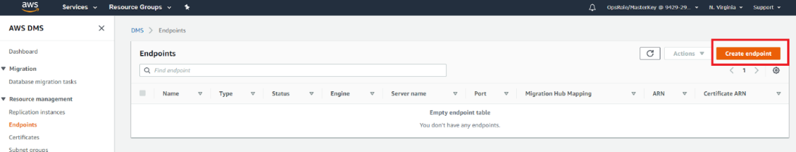

2.3. First, you’ll configure a source endpoint for SQL Server. Since our SQL Server is located in a different environment, leave the Select RDS DB instance parameter unchecked.

Make sure the Source endpoint box is checked. Enter a relevant name under the Endpoint identifier text box. Then, choose Mirosoft SQL Server for the Source engine. Another dialogue should appear named Access to endpoint database. Choose Provide access information manually.

Next, lets pre-fill some of the SQL Server DB server details.

ServerName: <EC2Hostname>

Port: 1433

UserName: awssct

Password: Password1

DatabaseName: dms_sample

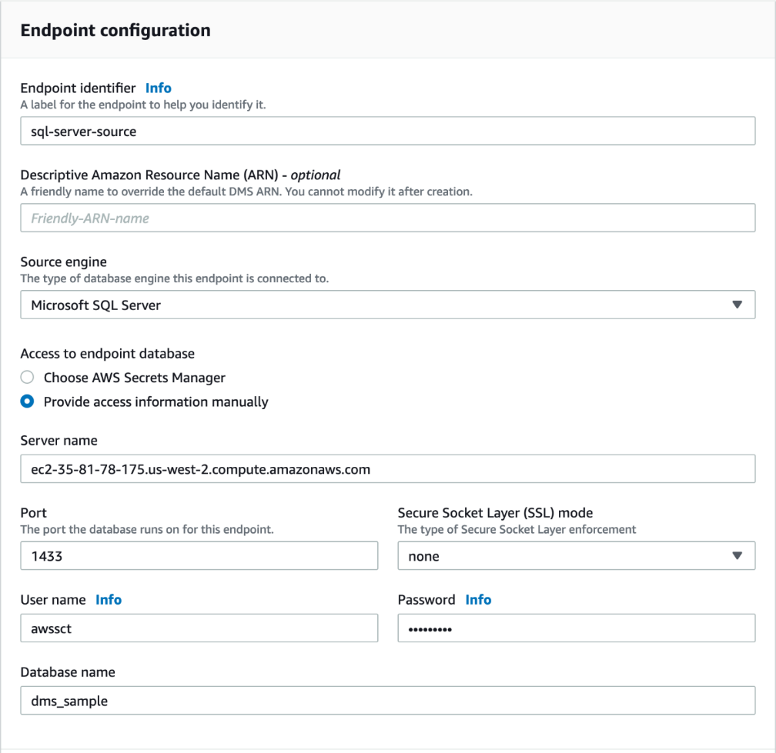

2.4. You'll expand the option Test endpoint connection (optional) option and select the generated VPC and then click Run test. Once the test is successful, click Create endpoint.

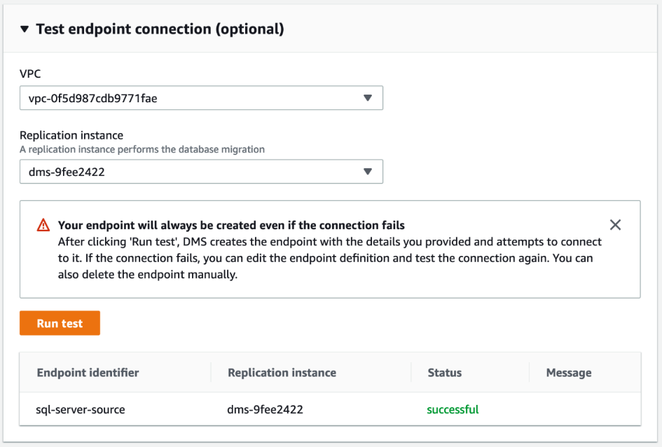

2.5. Next, you'll configure a target endpoint for Redshift.

Make sure the Target endpoint box is checked. Enter a relevant name under the Endpoint identifier text box. Then, choose Amazon Redshift for the Target engine. Another dialogue should appear named Access to endpoint database. Choose Provide access information manually. Please input below:

ServerName: [Redshift-Endpoint]

Port: [Redshift-Port]

UserName: [Redshift-User]

Password: [Redshift-Password]

DatabaseName: [Redshift-Database]

If your connection is failing, make sure that your [Redshift-Cluster-Endpoint] ends with amazonaws.com. For example, if your endpoint is redshiftcluster-jnich0gd7w8a.czx7aqrjspud.us-west-2.redshift.amazonaws.com:5439/dev, trim it to redshiftcluster-jnich0gd7w8a.czx7aqrjspud.us-west-2.redshift.amazonaws.com.

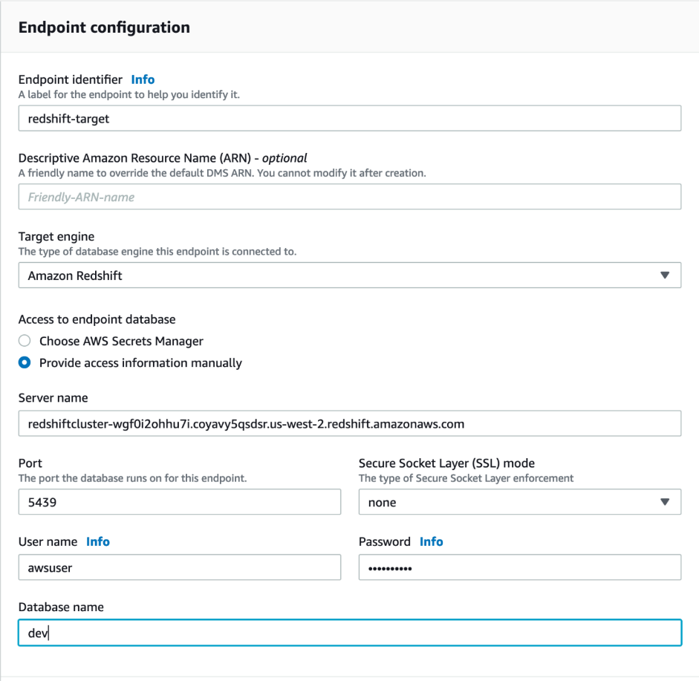

Click on the Endpoint settings dropdown and then click on the Add new setting button. Under the Setting key, choose ExplicitIds and type true as the value. This setting allows tables with IDENTITY columns to override their auto-generated values with explicit values loaded from the source data files.

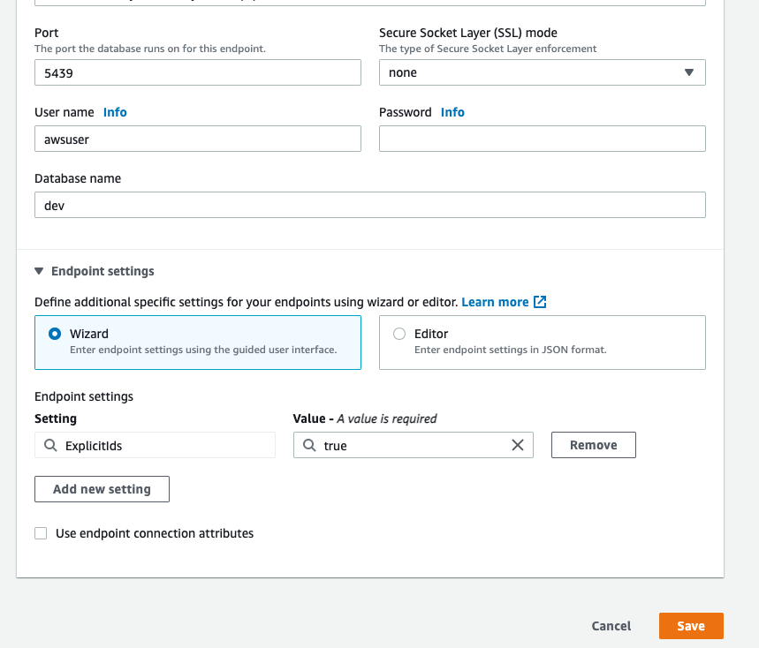

You'll expand the option Test endpoint connection option and select the generated VPC and then click Run test. Once the test is successful, click Create endpoint.



You can now see both our source and target endpoints.

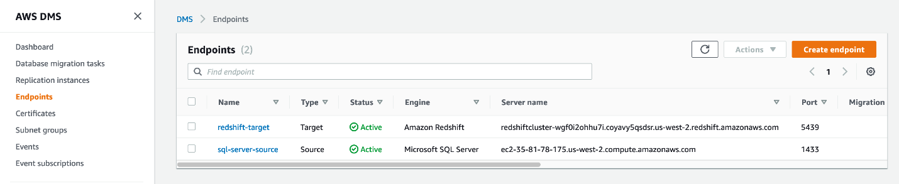

2.6. Our last configuration step is to create a replication task, which will take care of the data migration. Navigate to Database migration tasks and click Create Task.

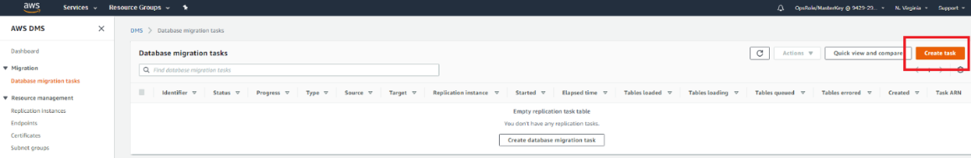

You need to privide any meaningful name in the Task identifier field. Select the DMS replication instance that was generated by the CloudFormation template. Then, select the source and target endpoints you created in the previous steps. For the option Migration type, click Migrate existing data and replicate existing changes.

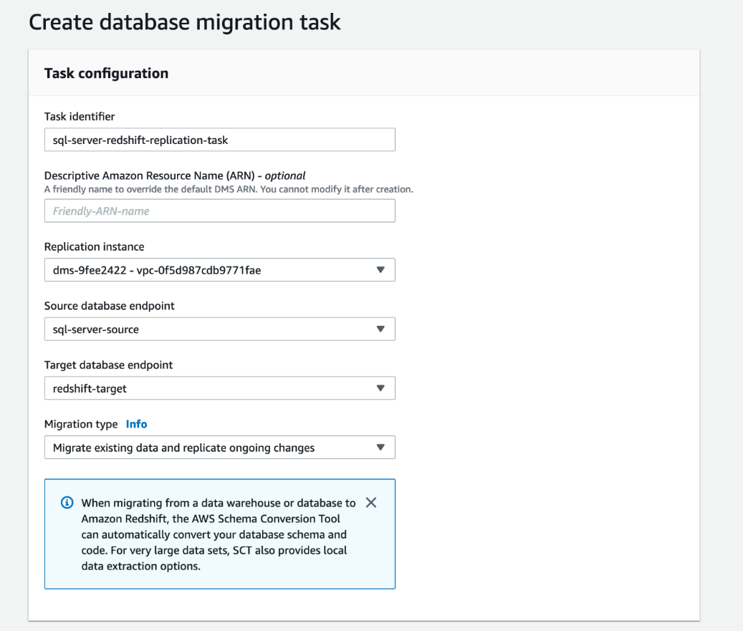

Next, under Task settings, you'll go with all default options except for Target table preparation mode, where you will need to select Do nothing as you already created all tables using AWS Schema conversion tool earlier.

Also, tick Enable CloudWatch logs to view DMS logs in case something going wrong.



For the next section under Table mappings, click JSON editor. Paste in the code below:

{

"rules": [

{

"rule-type": "selection",

"rule-id": "1",

"rule-action": "include",

"object-locator": {

"schema-name": "dbo%",

"table-name": "%"

},

"rule-name": "1"

},

{

"rule-type": "transformation",

"rule-id": "2",

"rule-name": "2",

"rule-action": "rename",

"rule-target": "schema",

"object-locator": {

"schema-name": "dbo"

},

"value": "dms_sample_dbo"

}

]

}

Click Create task on the bottom of the page.

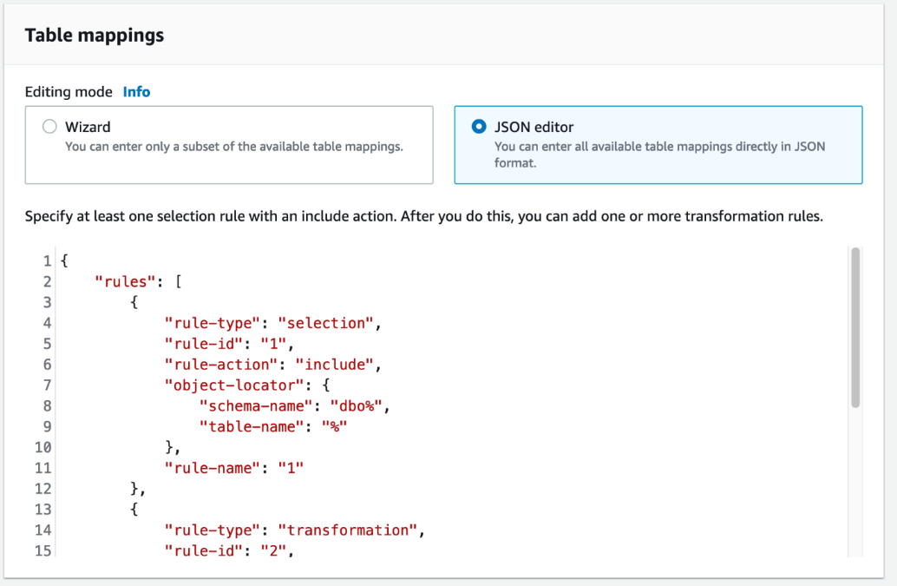

2.7. Now, you will run the migration, which will migrate all existing data from Oracle to Redshift and then also take care of Change data capture (CDC) to cater ongoing changes.  
Select the replication task and follow through with Action > Restart/Resume once the creation process is complete.

If the DMS replication task is failing, you may have missed any of the steps above.

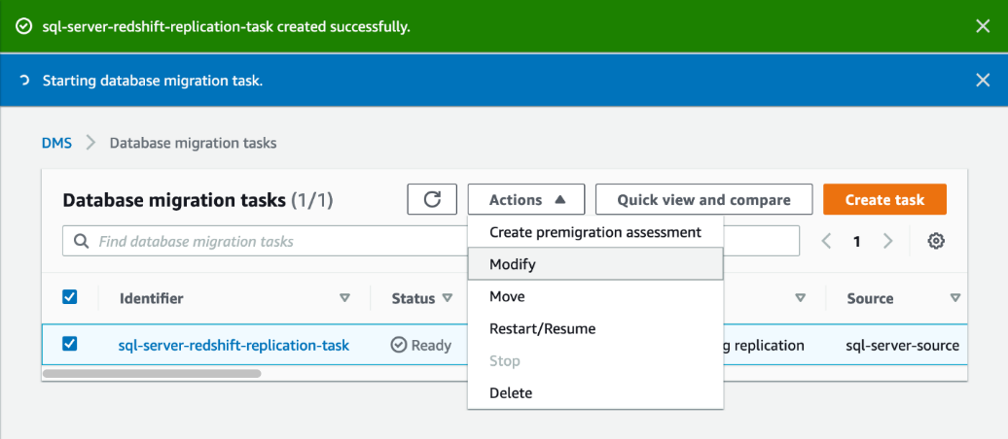

If you want to view the statistics of what data is getting transferred, you can go to the summary page, which allows you to view the statistics of how many records are getting transferred via DMS.

Click full load task and click Table statistics.

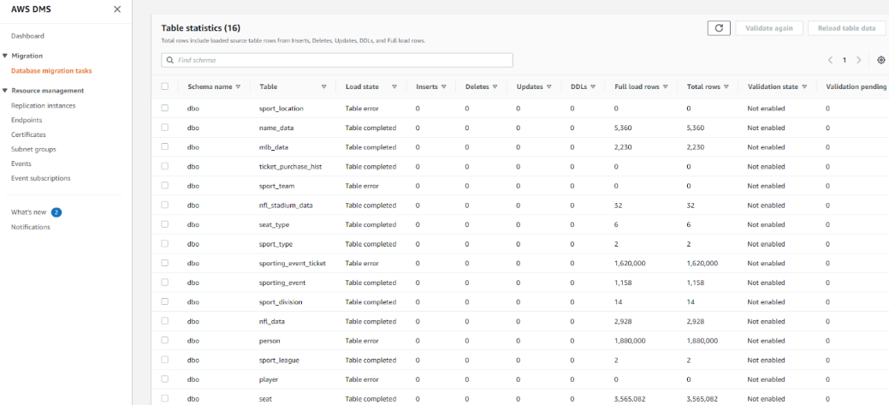

2.8. You can verify the same in SQL Workbench/J. Execute the same command executed earlier in SQL Workbench/J to view the record count.

select t.table_schema, t.table_name,i.tbl_rows

from svv_tables t left join svv_table_info i

on t.table_schema = i.schema and t.table_name = i.table

where t.table_type = 'BASE TABLE' and t.table_schema='dms_sample_dbo'

order by 1,2

You can see all these tables got loaded with data in Redshift.

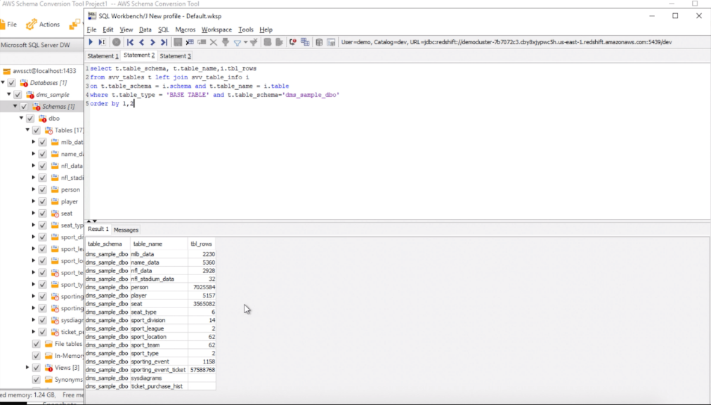

## [3. Keep the Data in Sync](https://catalog.us-east-1.prod.workshops.aws/v2/workshops/9f29cdba-66c0-445e-8cbb-28a092cb5ba7/en-US/lab12" \l "3.-keep-the-data-in-sync)

Now, you will verify the Change Data Capture (CDC) functionality of DMS to make sure ongoing changes are automatically replicated from SQL Server to Redshift.

3.1. In our dataaset, you have a table sport_type with just 2 records in it. You will now insert some records on the SQL Server side to verify if that gets replicated to Redshift.

Execute the command below in SQL Workbench/J to view the data in the sport_type table in Redshift.

1

select * from dms_sample_dbo.sport_type order by 1;

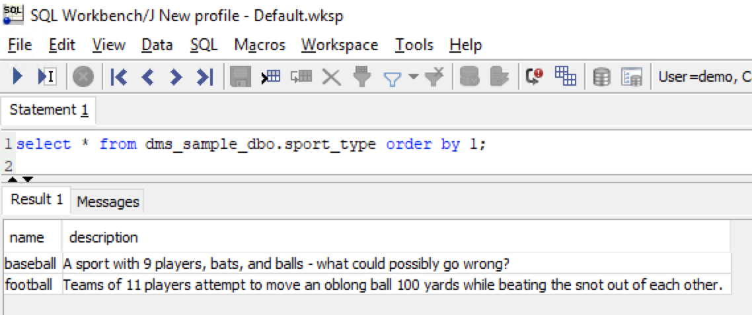

3.2. Now, lets take a look of the same table on the SQL Server side, which should show the same two records. Execute the command below in SQL Server Management Studio to view the data in the sport_type table.

use dms_sample;

select * from dms_sample.dbo.sport_type order by 1;

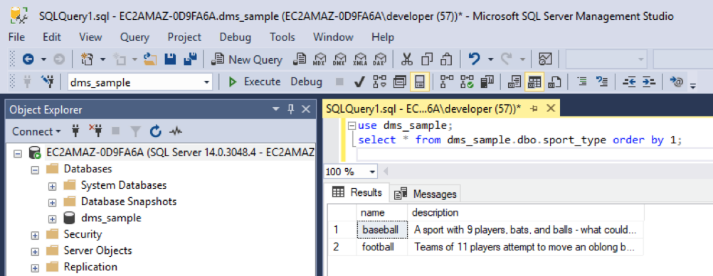

3.3. You want to confirm that the CDC process is operational. For that, you will insert some records in the sport_type table in SQL Server. Execute the command below in SQL Server Management Studio to insert five records in sport_type table.

use dms_sample;

insert into dbo.sport_type(name,description)

values

('hockey','A sport in which two teams play against each other by trying to more a puck into the opponents goal using a hockey stick'),

('basketball','A sport in which two teams of five players each that oppose one another shoot a basketball through the defenders hoop'),

('soccer','A sport played with a spherical ball between two teams of eleven players'),

('volleyball','two teams of six players are separated by a net and each team tries to score by grounding a ball on the others court'),

('cricket','A bat-and-ball game between two teams of eleven players on a field with a wicket at each end');

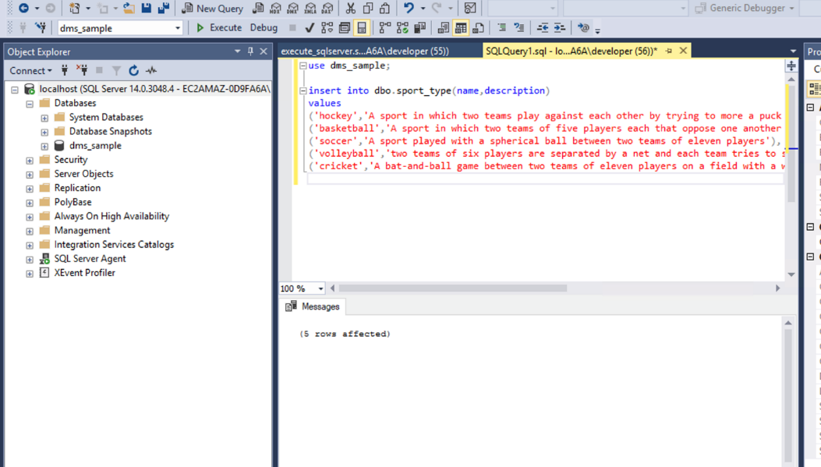

3.4. Execute below command in SQL Server Management Studio to view data in the sport_type table. You should see new rows added.

use dms_sample;

select * from dms_sample.dbo.sport_type order by 1;

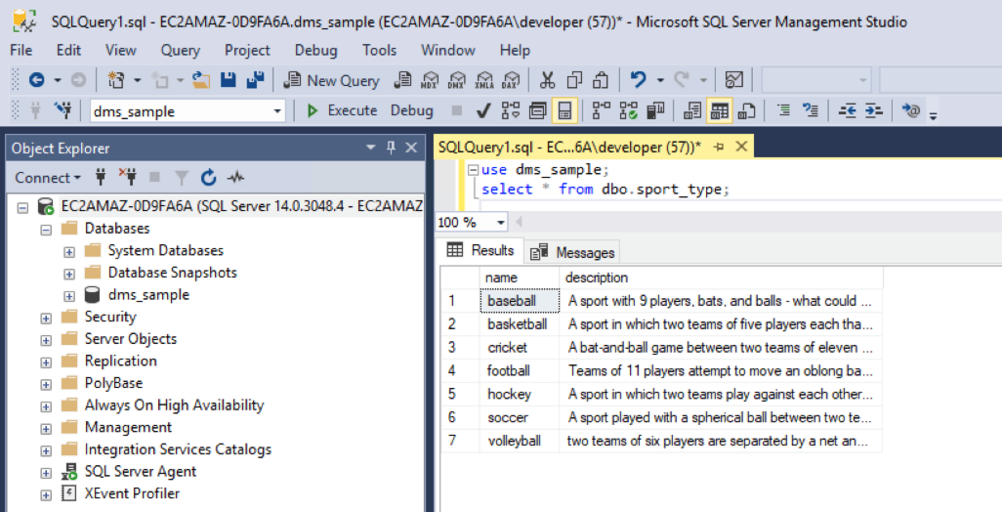

3.5. Now, you'll go back to Redshift and see the records there. Execute the command below in SQL Workbench/J to view the sport_type table.

select * from dms_sample_dbo.sport_type order by 1;

You should see the newly inserted records there too.

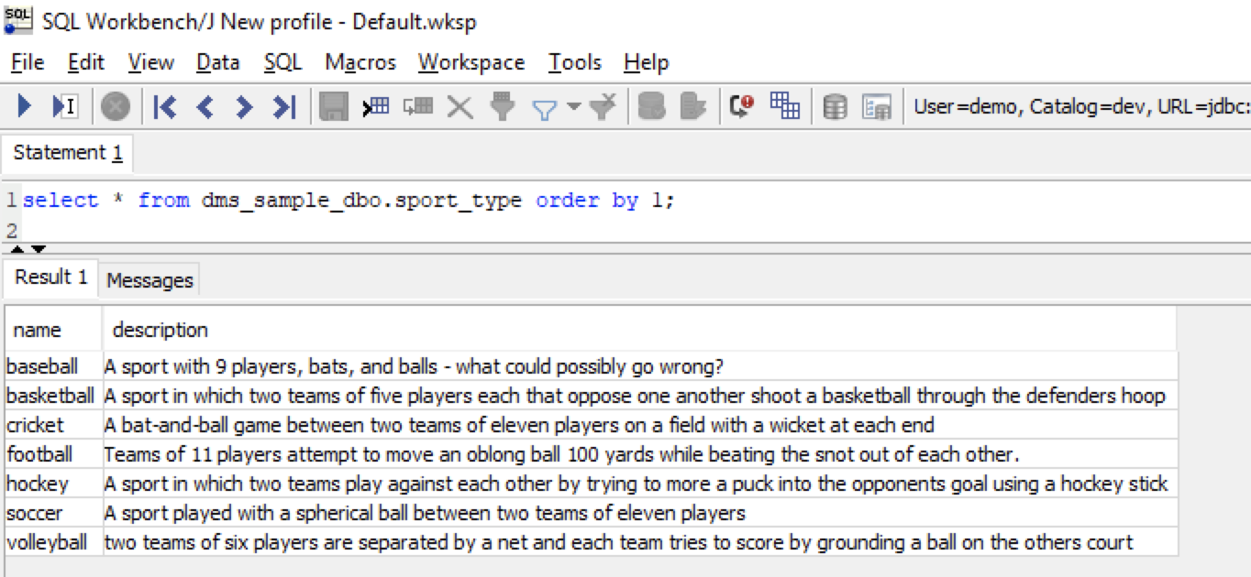

3.6. You can view the logs of the CDC process to see tabular metrics in the DMS console. Navigate to DMS service in AWS console and select the Ongoing Replication task and click Table statistics.

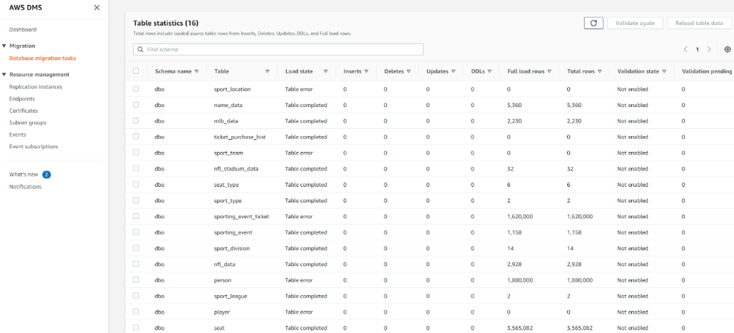

## [Before You Leave](https://catalog.us-east-1.prod.workshops.aws/v2/workshops/9f29cdba-66c0-445e-8cbb-28a092cb5ba7/en-US/lab12" \l "before-you-leave)

If you are done using your lab environment, please consider decommissioning it to avoid having to pay for unused resources. Moreover, make sure to delete DMS endpoints, replication task(s), and DMS instance prior to deleting your CloudFormation template. If you plan on doing Lab 11 or Lab 18, you can leave this CloudFormation stack running as both of those labs reference these same resources.